PewPew Squad

Condo Management System Project:

Condofy

Compiled Report

Gevorg Alaverdyan #40202177

Ramy Attalla #40205642

Khashayar Azad #40211574

Sophie Hajjar #40210405

Yeprem Antranik #40204291

Mario El Shaer #40210124

Omar Shehata #40164193

Tarek Elalfi #40197527

Jay Patel #40203705

Khaled Saleh #40210125

01-05-2024

Table of content

**Software Product Vision 5**

1. Introduction 5

2. Positioning 5

2.1. Problem Statement 5

2.2. Product Position Statement 6

3. Stakeholder and User Descriptions 7

3.1. Stakeholder Summary 7

3.2. User Summary 9

3.3. User Environment 10

3.4. Key Stakeholder or User Needs 10

3.5. Alternatives and Competition 11

4. Product Overview 12

4.1. Product Perspective 12

4.2. Assumptions and Dependencies 12

5. Product Features 13

**BackStories 15**

Sprint 1: 15

Sprint 2: 16

Sprint 3: 18

Sprint 4: 21

**Software Architecture Document (SAD) 25**

1.1 Identifying information. 25

1.2 Supplementary information 25

1.3 Other information 26

1.3.1 Overview 26

1.3.2 Architecture evaluations 26

1.3.3 Rationale for key decisions 26

2.Stakeholders and concerns 26

2.1 Stakeholders 27

2.2 Concerns 27

2.3 Concern–Stakeholder Traceability 29

3.Viewpoints+ 30

3.1 Typical stakeholders 32

3.2 Model kinds+ 33

3.3 Correspondence Rules 34

3.4 Operations on views 35

3.6 Correspondence rules 36

4.Views 37

4.1 Scenarios View 38

4.1.1 Use Cases Related to all Users 38

4.1.2 Use Cases Related to Owners 40

4.1.3 Use Cases Related to Managers 41

4.1.4 Knowns issues 41

4.2 Logical View 42

4.2.1 Components 42

4.2.2 Known issues 43

4.3 Process View 43

4.3.1 Activity diagram 44

4.3.2 Known issues 44

4.4 Domain Model and Class Diagram 44

4.5 Deployment View 48

4.5.2 Known issues 49

5.Consistency and correspondences 50

5.1 Known inconsistencies 50

5.2 Correspondences in the AD 51

**Risk Assessment and Management Plan (RMP) 52**

1. Introduction 52

2. Understanding used Metrics 52

3. Risk Assessment and Management Plan 53

4. Risk Matrix 54

**Testings 61**

Sprint 2 61

Sprint 3 61

Sprint 4 62

**Sprint Retrospectives 63**

Introduction 63

Sprint 2 63

Sprint 3 64

Sprint 4 66

**Release Plan 68**

Deployment: 68

Sprint 1 68

Sprint 2 69

Sprint 3 70

Sprint 4 71

Sprint 5 71

**UI Prototypes – User Stories 72**

**Testing Plan 82**

Testing Tools and Approach 82

Code Coverage: 82

Tools for Manual Testing: 82

Manual Testing: 82

Developer-level Testing: 83

Unit Testing: 83

Integration Testing: 83

Metrics and Coverage 84

Code Metrics: 84

Test Execution 87

Test Environment 87

Sprint 3 88

Acceptance Test Scenario 88

Sprint 4 89

Acceptance Test Scenario 89

**Code Management 91**

Design Patterns 91

Singleton Pattern 91

Observer Pattern 92

Model-View-Controller (MVC) 93

Source Code Documentation 95

Bug Report 98

Design Quality 102

Modularization 102

Refactoring Efforts 103

Static Analysis & Code Review Tools 104

Use of Feature Branches 107

**Deployment 109**

# 

# **Software Product Vision**

# Introduction

The purpose of this document is to collect, assess, and explain the Condo Management System's needs and functionality. It highlights the fundamental skills looked by stakeholders and target users, as well as the justification for these specified requirements.

# Positioning

## Problem Statement

Summary of the problem being solved by this project:

| The problem of | Inefficiency of condominium management processes and lack of a digital platform |
| --- | --- |
| affects | Condo management companies, condo owners and condo renters |
| the impact of which is | Delays in job completion, difficulty in obtaining essential financial or property data, and an overall deficiency of unity in reservations, resulting in discontent and inadequate living conditions. |
| a successful solution would be | A simplified condo management system that provides features for task assignment, financial tracking, and centralized communication. |

## Product Position Statement

Overall statement summarizing the position the product intends to fill in the marketplace:

| For | Condo management companies, condo owners and condo renters |
| --- | --- |
| Who | Seek a modernized, unified, and user-friendly approach to effective condo management, and communication |
| The (product name) | is a Condo Management System |
| That | Provides:   * Streamlined communication: Updates for effective information exchange between stakeholders. * Clear Financial Tracking: Visibility into financial reports. * Reservations and event system: Facilitates booking for accessible activities and event organization. * Easy information management and access: Instant access to essential condo data such as parking spots, unit id, and more. |
| Unlike | Existing apps or traditional manual management or limited digital alternatives. |
| Our product | Distinguishes itself from competitors in the market by combining fundamental management functionalities with a simple interactive platform for users in a unique way that promotes a great condominium living experience, all this for free. |

# Stakeholder and User Descriptions

The lists of stakeholders and users below represent both system users and non-users, who have been identified. Their needs, their responsibilities within the system, and the main issues they believe the suggested solution addresses are also described in this section.

## Stakeholder Summary

A list of stakeholders that are only focused on the system's development. (They are not the end users):

| **Name** | **Description** | **Responsibilities** |
| --- | --- | --- |
| Project Manager | The project manager is responsible for the planning, execution and the supervision of the project while assuring effective goal-achieving within the limitations of scope, time, and money. | * Defines the timeline to ensure the delivery of the project. (Feasibility) * Defines the best methodology. (Effectiveness) * Defines project scope while managing risks and budget. (Feasibility) * Ensures the system meets the requirements. (Correctness) |
| Developer | The developer is involved in the system’s configuration, maintenance, and support. | * Writes and implements code easily understandable, adjustable and expandable. (Maintainability) * Writes code that meets specific requirements and performance. (Reliability) * Prevents system failures. (Robustness) |
| Software Architect | The software architect designs high-level structures and creates technical specifications for platforms, frameworks, and technology. | * Designs system architecture that ensures the adaptation of the system to a new environment. (Maintainability) * Designs a user-friendly system. (Usability) * Designs independent and upgradable components. (Scalability) * Finds technology that aligns with the long-term business strategy and provide a competitive advantage. (Functionality) |
| Tester | The tester checks the artifacts and behavior of the system under validation and verification. | * Determines how easy the system to test to find bugs or ensure that it meets all predefined criteria. (Testability) * Makes sure that all possible scenarios are covered by the tests (Correctness) |
| Customer | The entity or organization that has commissioned the construction of the condo management app and its related product. | * Clearly state the aims and needs of the condo management system. * Review and approve essential deliverables to ensure they are consistent with the objectives. |
| Product Owner | An individual or team in charge of advocating the customer's interests and ensuring that the finished product satisfies their specifications. | * Act as a bridge between the development team and the customer. * Accept or reject deliverables according on whether they match the acceptance criteria and business needs. * Continuously review and enhance the product in response to customer input and changing company demands. |
| Users | A varied user base, including public users (condo owners, rental users), as well as condo management firm workers, that will interact with the product. | * Use most of the features of the product. * Has a profile * Receives notifications. * See information about the condos |

## User Summary

A list of identified users of the system and in what functionalities they will be using in the system:

| **Name** | **Description** | **Responsibilities** | **Stakeholder** |
| --- | --- | --- | --- |
| Condo management companies | Condo management companies are intermediaries between public users and the system | * Create a profile for a property under their management.   + Upload condo files.   + Enter detailed information.   + Send registration keys to unit owners or rental users. * Enter condo fees and costs for operations. * Set up common facilities. * Set up different roles for different employees. * Can choose to list and coupons/offers. | Customer & Users |
| Employees  (Managers, Accountant, Staff) | Condo management companies will assign different responsibilities to employees.  They can be a manager who oversees the chores and personnel, an accountant who handles the condominiums' currency, or a staff member who works in various condo services. | Employees:   * Complete task they received as notification.   Managers:   * Manages tasks.   Accountants:   * Tracks finances through the financial system.   Staff:   * Addresses requests based on daily operations. | Users |
| Condo Owners | Condo owners are accountable and have ownership rights for specific condo units. | * Create an account. * Access information about their properties. * View financial status. * Reserve common facilities. * Receive notification of latest activities. * Submit requests e.g. intercom changes, reporting violations, etc. | Users |
| Condo renters | Condo renters are people who live in a condo but do not have ownership of it. They have rights and obligations related to their rental agreement. | * Create an account. * Access information about their properties. * Reserve common facilities. * Receive notification of latest activities. | Users |

## User Environment

The ideal working environment of the target user should be:

* Public users are expected to have a device with internet connectivity in order to access the website and sign in to their accounts to verify any information regarding their condo.
* Condo management companies will have to access the system the same way as a public user except that they will be able to see different functionalities.

## Key Stakeholder or User Needs

List of the key problems with existing solutions as perceived by the stakeholder or user.

| **Need** | **Priority** | **Concerns** | **Current Solution** | **Proposed Solutions** |
| --- | --- | --- | --- | --- |
| **Condo Management Companies** | | | | |
| Ineffective condo file management | High | Time-consuming file retrieval | None | Centralized digital storing method for digital files |
| Difficult financial tracking | High | Ease of forgetting or miscalculating | None | Streamline financial tracking |
| Disorganized reservation system | Medium | Ambiguity about bookings and facilities availability | None | Streamline the reservation system |
| **Employee** | | | | |
| Inefficient assignment of requests | High | Difficulty in assigning requests to the right employee. | None | Implement an automated system to send the request to the relevant staff member |
| **Condo Owner** | | | | |
| Limited property insights | High | Disorganized visibility of property-related information | None | Provide a comprehensive presentation of property details. |
| Inconvenient request submission | High | Difficulty in process for submitting requests | None | Design a request submission interface |
| Difficult financial tracking | High | Unclear financial statement of property | None | Streamline financial tracking |
| **Condo Renter** | | | | |
| Unpractical reservation system | Medium | Ease of misunderstanding regarding reservations | None | Implement reservation system to accommodate renters |
| Insufficient information on condo fees | High | Lack of clarity on associated fees for rented units | None | Improve transparency in presenting condo fee details for renters |

## Alternatives and Competition

The identification of alternatives the stakeholder perceives as available:

* Apps such as *Buildium* or *Property Vista*: Property management software
  + Strengths: Offers good features such as leasing experience, accounting, building maintenance and more.
  + Weakness: Has a monthly-fee and is not focused on the administration of the Condo management companies.
* Traditional manual management or limited digital alternatives: Relies heavily on paper-based documentation and manual record-keeping. Limited use of technology for managing financial transactions and property information.
  + Strengths: Familiarity of the stakeholders, and minimal investment in technology.
  + Weakness: Time-consuming and prone to human errors, lack of real-time information, and reduced accessibility.

# Product Overview

This section provides a view of the product capabilities, and disadvantages that could lead to modifications of the documentation.

## Product Perspective

The condo management system is designed to simplify a few condominium administration tasks. It serves condo owners, renters, employees, and condo management companies. The main goal is to offer an all-inclusive platform for condo management, including financial tracking, communication, and reservations for common areas and duties.

## Assumptions and Dependencies

List of factors that affects the features stated in this document and assumptions that, if changed, will alter thedocument:

| **Factor** | **Assumption** | **Change** |
| --- | --- | --- |
| Availability of Internet Access | Users have access to the internet for using the app and website. | If a significant user base lacks reliable internet access, an alternative offline functionality might need consideration. |
| Security Measures | The implementation of adequate security measures to protect user data. | Any compromise in security could lead to unauthorized access, affecting user trust and necessitating changes in security protocols. |
| User Profiling Accuracy | Users provide accurate and up-to-date information for their profiles. | Inaccurate user profiles may affect the effectiveness of features like financial calculations and request assignment. |

# Product Features

List of the main features with a general description and their priority regarding the design of the system:

| **Feature** | **Priority** | **Description** |
| --- | --- | --- |
| Security and authentication | High | Users will have to authenticate to ensure security of their privacy. |
| User profile | High | Users can create and edit their profiles with a profile picture, user name, contact email, and phone number. |
| Registration Key Validation | High | Users must get a registration key from their condo management company to become condo owners or condo renters in the system. |
| Condo Owner Dashboard | High | Condo owners have a simple dashboard displaying property information, financial status, and the status of submitted requests. |
| Property Profile Creation | High | Condo management companies may build profiles for properties under their control, which include the property name, unit count, parking count, locker count, and location. |
| File Upload and Sharing | High | Condo management companies can upload and share condo-related files with all condo owners on a certain property. |
| Detailed Unit Information | High | Condo management companies can enter specific information about each condo unit, such as the size, owner, occupant data, and associated condo fees. |
| Financial System | High | Condo management companies can set condo fees, compute unit fees, maintain an operational budget, and input operational costs. The system can create annual financial reports. |
| Reservation System | High | Condo management companies can set up common facilities for reservation. Users can book facilities (e.g. sky lounge, a spa fitness) through a calendar interface, and availability is displayed. |
| Employee Role Management | High | Condo management companies can assign different roles (e.g., manager, finance) to employees. |
| Request Submission and Assignment | High | Condo owners can submit various requests (e.g., move-in/out, maintenance). Each request is assigned to the appropriate staff based on type. |
| Notification System | High | Users have a notification page showing the latest activities (submitted or assigned requests). |
| Forum for User Discussions | Medium | Users can post and reply to discussions in a forum. |
| Event Organization and Invitation | Medium | Users can organize events and invite others. |
| Discounts and Offers | Medium | Condo management companies can list coupons/offers visible to all unit owners or rental users of one property. |
| Cross-Platform Accessibility | Low (Bonus) | The app is accessible on Android, iOS, Linux, MacOS, and Windows platforms. |
| Multilingual Support | Low (Bonus) | The app is available in English and at least one other language. |
| Single Sign-On Integration | Low (Bonus) | Users can log in using their Gmail account or other compatible accounts, offering Single Sign-On (SSO) functionality. |

# **BackStories**

Features:

Below is a list of the features completed in each sprint. Following standard software practices, Jira is used as the project management software. All features, gathered from the requirements document provided, are presented as epics, all epics are divided into user stories and all user stories are broken down to subtasks. Non-technical tasks and bugs were omitted from this document.

User story points (USPs) from 1-5 are assigned to each user story. The scale is defined as follows: 1 story point represents 4 hours of work.

All “tickets” (epics, stories, subtasks) have ids corresponding to their Jira ids. For example, Epic CN-1 corresponds to ticket CN-1 in Jira.

## Sprint 1:

| **User Story ID** | **USP** | **Priority** | **Status** |
| --- | --- | --- | --- |
| **User Authentication (Epic CN-1)**   * Public users can create their own (unique) profile. The minimum information needed in a profile is below.   + A profile should at least include a profile picture, user name, contact email, phone number. * Condo management companies can set up different roles for different employees, who are responsible for the same property. Such roles include manager, or someone who is responsible for daily operations, or someone who is responsible for finance. |  |  |  |
| Font-end User sign-in (User Story CN-3)  As a user, I want a straightforward and accessible login interface so that I can easily sign in to my account. | 3 | High | DONE |
| Frontend - User Registration (User Story CN-2)  As a user, I want an intuitive and user-friendly interface for registering an account so that I can easily sign up for the condo management services. | 3 | High | DONE |
| Backend - User Registration (User Story CN-14)  As a public user, I would like to be able to sign up and as a manager, I would like to be able to register my employees | 5 | High | DONE |
| Backend - User Sign-in (User Story CN-15)  As a user, I would like to be able to sign in and remain authenticated. | 5 | High | DONE |
| Backend - Implement endpoint for managing user information (User Story CN-37)  As a user, I would like to be able to view and modify my profile data. | 3 | Medium | DONE |
| Frontend - User Profile page (User Story CN-31)  As a user, I want a straightforward and accessible profile page where I can edit all of my relevant information. | 3 | Medium | PUSHED TO  SPRINT #2 |
| Frontend - Company registration (User Story CN-39)  As a manager, I would like to be able to sign my company up. | 3 | High | DONE |
| **Total USP** | 25 |  |  |

## Sprint 2:

| **User Story ID** | **USP** | **Priority** | **Status** |
| --- | --- | --- | --- |
| **User Authentication (Epic CN-1)** |  |  |  |
| Frontend - User Profile page (User Story CN-31)  As a user, I want a straightforward and accessible profile page where I can edit all of my relevant information. | 3 | High | DONE |
| **Property Management (Epic CN-54)**  This epic tracks the creation and management of buildings, units, storage/parking from the Company’s perspective. As well as the ability for users to view their information as required:  **Registration for public users:**  “Public users need to provide a registration key obtained from their condo management company to become condo owners in the system.  Public users need to provide a registration key obtained from their condo management company to become rental users in the system.”  **Public users access:**  “Condo owners can have a good view (dashboard) of their properties, including general information.”  **Companies**  **“**Condo management companies can create a profile for a property under their management.” |  |  |  |
| Frontend - Property Dashboard (Company) (User Story CN-53)  As a company manager, I want to view a dashboard showing all the properties belonging to my company, so that I can easily manage them. | 3 | High | DONE |
| Frontend - Create Property/Building Page (User Story CN-55)  As company manager, I want to create and manage condo property profiles, so that all necessary property details are available to owners and tenants. | 3 | High | DONE |
| Frontend - Unit Dashboard Page for parent Building (CN-56)  As company manager, I want to create and manage condo property profiles, so that all necessary property details are available to owners and tenants. | 3 | High | DONE |
| Frontend - Create Unit Page  As company manager, I want to enter detailed information for condo units. | 3 | High | DONE |
| Backend - Condo Management (CN-65)  As a user, I want to have the expected access to properties. Managers must be able to create, view, delete, and modify properties. Owners must be able to view their properties. | 5 | High | DONE |
| Backend - Condo registration (CN-66)  As a public user (owner/tenant), I must be able to register my property to my account. | 3 | High | DONE |
| Backend - Parking & Storage (CN-67)  As an owner, I must be able to view properties linked to my condo (unit, parking, storage) and as a manager, must be able to manage this. | 3 | Medium | DONE |
| **Mobile Application (Epic CN-54)**  This Epic tracks the mobile application progress, which according to the requirements is an app that contains all the same core functionalities: **“**The simplified condo management app and its companion Web site must have of these following core functionalities**”** |  |  |  |
| Sign In Page  As a user, I would like to be able to sign in to the app. | 2 | Medium | DONE |
| **Total USP** | 25 |  |  |

## Sprint 3:

| **User Story ID** | **USP** | **Priority** | **Status** |
| --- | --- | --- | --- |
| **Employee Management (Epic CN-64)**  Company managers must be able to remove, add and view all company employees. |  |  |  |
| Frontend - Create Employee (Mobile and Web) (User Story CN-59)  As a company manager, I would like to be able to create an employee with a role assigned to him. | 5 | High | Partially Done |
| Backend - Get Company Employees (User Story CN-129)  As a manager, I would like to be able to view all my managers. | 2 | High | DONE |
| Frontend - Employee Management Dashboard (User Story CN-58)  As a company manager, I want to view a dashboard showing all the properties belonging to my company, so that I can easily manage them. | 3 | High | DONE |
| Backend- Manage a unit’s financial status (User Story CN-132)  As company manager, I would like to be able to view and modify the financial status of all properties. | 4 | High | DONE |
| **Mobile Application (Epic CN-87)**  This Epic tracks the mobile application progress, which according to the requirements is an app that contains all the same core functionalities: **“**The simplified condo management app and its companion Web site must have of these following core functionalities**”** |  |  |  |
| Mobile - Sign Up Page (All Users)  As a company manager, I would like to be able to sign myself and my company up.  As a public user, I would like to be able to sign myself up and use my registration key. | 3 | Medium | DONE |
| Mobile - User Profile  As a user, I would access to my profile page and would like to be able to modify all my relevant data as expected. | 2 | Medium | DONE |
| Mobile - Main Authentication (Epic CN-87)  When the user signs in we must maintain authentication as we do on web. | 3 | Medium | DONE |
| **Property Management (Epic CN-54)**  This epic tracks the creation and management of buildings, units, and storage/parking from the Company’s perspective. As well as the ability for users to view their information as required:  Registration for public users:  “Public users need to provide a registration key obtained from their condo management company to become condo owners in the system.  Public users need to provide a registration key obtained from their condo management company to become rental users in the system.”  Public users access:  “Condo owners can have a good view (dashboard) of their properties, including general information.”  Companies  “Condo management companies can create a profile for a property under their management.” |  |  |  |
| Frontend - Owner Dashboard (Units. personal info) (User Story CN-123)  As an owner, I would like to be able to view my properties and their financial status in the dashboard. | 4 | High | DONE |
| **Property Financial System (Epic CN-124)**  The condo management system contains a simplified financial system.  Condo management companies can enter condo fee per square foot, per parking spot.  Condo fee of each unit will be calculated and presented to unit owners.  The financial system records operational budget (i.e., the collected condo fee) and cost. Condo management companies can enter the cost for each operation.  The financial system can generate an annual report. For example, all the condo fee collected for a given year. |  |  |  |
| Frontend- Owner view Financial Report (CN-139)  As an owner, I would like to be able to view all my assets' financial history. | 3 | High | PUSHED TO SPRINT #4 |
| Backend - Parking Price Calculation (CN-130)  As a company manager, I would like to enter condo fee per square foot, per parking spot. | 4 | High | DONE |
| Backend - Owner Financial Status (CN-131)  As an owner, I would like to be able to view my assets' financial status (balance, fees, and all other relevant data). | 3 | High | DONE |
| Frontend - Company Financial System (CN-125)  As a company manager, I would like to be able to view and modify the financial status of all assets. | 3 | High | DONE |
| Frontend - Employee Management Dashboard (CN-58)  As a company manager, I want to view a page displaying all the employees working for my company, so that I can easily manage them. | 3 | High | DONE |
| **Total USP** | 42 |  |  |

## Sprint 4:

| **User Story ID** | **USP** | **Priority** | **Status** |
| --- | --- | --- | --- |
| **Requests (Epic CN-155)**  Condo owners can submit requests.  Examples of such requests include moving in/out (date for reserving elevators), intercom changes, requesting access (fobs, keys), reporting a violation, reporting deficiency found in common areas, or asking a question.  Each request will be assigned to a corresponding employee based on the type of the request. |  |  |  |
| Backend - Handle requests (Company) (User Story CN-154)  As an employee, I would like to be able to handle requests relevant to my work. | 3 | High | DONE |
| Backend - Submit requests (Owner) (User Story CN-156)  As an owner, I would like to be able to submit a request specifying the issue and category. | 3 | High | DONE |
| Frontend - Employees handle requests (User Story CN-161)  As an employee, I would like to be able to handle a request. | 4 | High | TODO |
| Frontend - Owners submit requests (User Story CN-162)  As an owner, I would like to be able to submit a request. | 4 | High | DONE |
| **Building Facilities (Epic CN-152)**  The condo management system contains a simplified reservation system.  Condo management companies set up the common facilities, which require reservations. Examples include a sky lounge, a spa fitness.  The reservation system allows condo owners and rental users to reserve common facilities in a calendar-like interface.  The reservation system should show availabilities of common facilities.  The reservation is first-come-first-serve. Once a facility is booked, it will become unavailable for the reserved time. |  |  |  |
| Backend - Make Reservations (Public users) (User Story CN-153)  As a public user, I would like to be able to make reservations for any available facility in a building I am a part of. | 3 | High | DONE |
| Backend - Manage Facilities (Company) (User Story CN-151)  As a manager, I would like to be able to manage facilities for all my company’s properties. | 3 | High | DONE |
| Frontend - Company manages facilities (User Story CN-160)  As a manager, I would like to be able to manage facilities for all buildings. | 4 | High | DONE |
| Frontend - Facility Reservation (User Story CN-180)  As a resident, I want to view the building facilities included in the properties I own or rent and create or cancel reservations for these facilities, So that I can easily manage my access to these amenities and plan my usage according to availability. | 4 | High | DONE |
| **Property Financial System (Epic CN-124)**  The condo management system contains a simplified financial system.  Condo management companies can enter condo fee per square foot, per parking spot.  Condo fee of each unit will be calculated and presented to unit owners.  The financial system records operational budget (i.e., the collected condo fee) and cost. Condo management companies can enter the cost for each operation.  The financial system can generate an annual report. For example, all the condo fee collected for a given year. |  |  |  |
| Frontend- Owner view Financial Report (CN-139)  As an owner, I would like to be able to view all my assets' financial history. | 3 | High | DONE (Pushed from Sprint 3) |
| **Mobile Application (Epic CN-87)**  This Epic tracks the mobile application progress, which according to the requirements is an app that contains all the same core functionalities: **“**The simplified condo management app and its companion Web site must have of these following core functionalities**”** |  |  |  |
| Frontend - Manage Employees (mobile) (CN-164)  As a manager, I would like to be able to manage my employees from mobile. | 4 | High | TODO |
| Frontend - Owner dashboard (mobile) (CN-163)  As an owner, I would like to be able to view my dashboard on mobile. | 3 | High | TODO |
| **Employee Management (Epic CN-64)**  Company managers must be able to remove, add and view all company employees. |  |  |  |
| Frontend - Create Employee (Mobile and Web) (User Story CN-59)  As a company manager, I would like to be able to create an employee with a role assigned to him. | 5 | High | Partially Done |
| **Property Management (Epic CN-54)**  This epic tracks the creation and management of buildings, units, and storage/parking from the Company’s perspective. As well as the ability for users to view their information as required:  Registration for public users:  “Public users need to provide a registration key obtained from their condo management company to become condo owners in the system.  Public users need to provide a registration key obtained from their condo management company to become rental users in the system.”  Public users access:  “Condo owners can have a good view (dashboard) of their properties, including general information.”  Companies  “Condo management companies can create a profile for a property under their management.” |  |  |  |
| Frontend - Renter view unit (CN-158)  As a renter, I would like to view my rented unit. | 2 | Medium | DONE |
| Frontend - Link parking/storage to unit (CN-159)  As a manager, I would like to be able to link storage units and parkings to units. | 2 | High | TODO |
| **NO EPIC STORIES** |  |  |  |
| Backend - Dispatch Notifications  As a user, I would like to see notifications relevant to my requests and reservations. | 4 | High | DONE |
| **Total USP** | 42 |  |  |

# **Software Architecture Document (SAD)**

1.Introduction

## 1.1 Identifying information.

The purpose of the Condofy Condo Management System Architect (CCMSAD) is to offer a comprehensive insight into the architecture design of the Condofy Condo Management System, emphasizing key quality attributes: usability, availability, maintainability, and testability. These attributes have been selected due to their critical importance in shaping the design and construction of the system.

## 1.2 Supplementary information

* Date of Issue and Status:
  + February 28th, 2024.
  + Status: v0.5,
* Authors, Reviewers, Approving Authority, Issuing Organization:
  + Authors:
  + Reviewers:
  + Approving Authority:
  + Issuing Organization
* Change History:
  + February 9th: Initial writing of this document awaiting review for further changes and improvements.
* Summary:
  + The architecture document for the Condofy Condo Management System (CCMS) provides a detailed overview of its design, emphasizing key attributes such as usability, availability, maintainability, and testability. Covering essential functional requirements, quality attribute scenarios, and architectural insights, it offers a comprehensive understanding of CCMS's architecture.
* Scope:
  + Due to the relatively short duration of the project, the team has decided to add some constraints on the project.
    - No need for large scalability as the product will serve customers living in Montréal.
    - No localization, the only language in the application is English.
* Context:
  + The Condofy Condo Management System operates within the context of condominium management, addressing the needs and challenges faced by property managers, residents, and other stakeholders. External factors such as regulatory requirements, technological advancements, and market trends influence the system's design and evolution.

* Version Control Information:
  + Version Control Mechanism: Git
  + Web Repository Location: <https://github.com/Condofy24/CondoManagement>
  + Mobile Repository Location: <https://github.com/Condofy24/CondofyMobile>
* References:

[1] https://www.cs.ubc.ca/~gregor/teaching/papers/4+1view-architecture.pdf

## 1.3 Other information

### 1.3.1 Overview

The Condofy Condo Management System Architecture Description (CCMSAD) presents a comprehensive overview of the architecture governing the Condofy Condo Management System. It serves to encapsulate essential points regarding the system's design, structure, and functionality. The overview includes sections addressing the purpose, scope, and context of the architecture, providing readers with a holistic understanding of its significance and implications.

The remainder of this AD is organized to facilitate navigation based on stakeholders and concerns, ensuring that readers can easily access relevant information based on their interests and objectives.

### 1.3.2 Architecture evaluations

Any evaluations conducted on the Condofy Condo Management System Architecture will be documented, highlighting the findings, insights, and recommendations derived from the evaluation process. These evaluations serve to assess the effectiveness, efficiency, and suitability of the architecture in meeting its intended objectives and addressing stakeholder needs.

### 1.3.3 Rationale for key decisions

The Condofy Condo Management System Architecture Description (CCMSAD) includes rationale for each decision considered pivotal in shaping the architecture. These rationales provide insights into the thought process, considerations, and trade-offs underlying key architectural decisions, offering transparency and justification for the chosen architectural direction. Adhering to ISO/IEC/IEEE 42010 standards, the inclusion of rationale enhances the comprehensibility and traceability of the architecture description, fostering confidence in the architectural decisions made throughout the development process.

# 2.Stakeholders and concerns

Identifying stakeholders for the "Condo Management Systems" project is vital. Stakeholders are those with a vested interest or impact on the project. In this section, we pinpoint potential stakeholders, examine their concerns about the project's architecture, and establish a direct link between those concerns and the stakeholders involved. This helps ensure the project addresses everyone's needs, increasing the likelihood of success.

## 2.1 Stakeholders

1. Public Users (Condo Owners and condo renters) (PU): Individuals owning or renting condos, utilizing the system for personal profiles, property information, and community engagement.

2. Condo Management Companies (CM): Organizations managing properties, using the system for streamlined property management, financial records, and communication.

3. Project Managers (PM): is responsible for the planning, execution and the supervision of the project while assuring effective goal-achieving within the limitations of scope, time, and money.

4. Employees with Different Roles (Staff): Employees with specific responsibilities within a property, using the system for role-based tasks.

5. Developers: Professionals responsible for system design, development, and maintenance across platforms.

6. Software architect (SA): designs high-level structures and creates technical specifications for platforms, frameworks, and technology.

7. Tester: checks the artifacts and behaviors of the system under validation and verification.

8. Regulatory Authorities (RA): Government bodies oversee compliance with regulations related to the system.

9. System Administrators (Sysadmin): Individuals managing system configuration, maintenance, and monitoring.

10. Accountants (ACCT): Professionals reviewing financial reports for accuracy and compliance.

## 2.2 Concerns

1. Purpose(s) of the System-of-Interest:

1.1 User Management and Engagement:

* Ensuring users can easily create and manage their profiles.
* Facilitating communication and interaction between condo owners, rental users, and condo management companies.

1.2 Property and Financial Management:

* Streamlining the management of condo properties, including financial aspects.
* Providing tools for condo management companies to handle property-related tasks efficiently.

1.3 Operational Efficiency:

* Improving the efficiency of daily operations for condo management companies through features like reservation systems, request management, and role-based access controls.

1.4 Request Management:

* Provide a streamlined and user-friendly mechanism for condo owners to submit various types of requests.

1. Feasibility of Construction and Deployment:

2.1 Technical Feasibility:

* Ensuring the technical aspects of building the system, including the integration with external services, are feasible.

2.2 Financial Feasibility:

* Evaluating the cost-effectiveness of constructing and deploying the system within budget constraints.

2.3 Resource Feasibility:

* Assessing the availability of skilled resources and technologies required for development.

2.4 Time Feasibility:

* Developing a realistic timeline for construction and deployment, considering potential challenges and dependencies.

1. Potential Risks and Impacts:

3.1 Security Risks:

* Identifying potential security vulnerabilities in user data, financial information, and files.
* Technical: Inadequate security measures can lead to data leaks.
* Technical: Nonprotected routes in backend can lead unauthorized access.

3.2 Operational Risks:

* Schedule: Ambiguous activity diagrams may result in delays due to workflow misunderstanding.

3.3 Privacy Concerns:

* Ensuring compliance with privacy regulations to avoid legal and reputational risks.

3.4 Management risks:

* Unclear vision in product statement can lead to misalignment among team members.

1. Maintenance and Evolution:

4.1 System Maintenance:

* Establishing a plan for ongoing system maintenance, including bug fixes, updates, and security patches.

4.2 Evolution and Upgrades:

* Planning for future enhancements and upgrades to meet changing user needs and technology advancements.

4.3 Scalability:

* Ensuring the system architecture allows for scalability to accommodate future growth.

4.4 Regulatory Compliance:

* Staying informed about and adapting to changes in regulations affecting condo management systems.

## 2.3 Concern–Stakeholder Traceability

This association between potential Stakeholders and the potential concerns is recorded through the following simple table. Showing every Stakeholder and their concerns.

Table 2.1: showing association of stakeholders to concerns in an AD. The upper row represents Stakeholders from section 2.1 (labeled from 1 to 10 with their abbreviations) and the Leftmost column represents the Concerns from section 2.2(labeled from 1.1 to 4.4)

| 2.2/2.1 | PU | CM | PM | STAFF | DEV | SA | Tester | RA | Sysadmin | ACCT |
| --- | --- | --- | --- | --- | --- | --- | --- | --- | --- | --- |
| 1.1 | X | X |  |  |  | X | X |  |  |  |
| 1.2 | X | X |  |  |  |  |  |  |  | X |
| 1.3 | X | X | X | X | X | X | X |  | X | X |
| 1.4 | X | X | X | X | X | X | X |  | X |  |
| 2.1 |  |  | X |  | X | X |  |  |  |  |
| 2.2 |  |  | X |  |  |  |  | X | X |  |
| 2.3 |  |  | X |  |  | X | X |  | X |  |
| 2.4 |  | X | X |  | X |  |  |  |  |  |
| 3.1 | X | X | X |  | X | X | X |  |  |  |
| 3.2 |  | X | X |  | X | X | X |  |  | X |
| 3.3 | X |  |  |  | X | X | X | X |  |  |
| 3.4 |  | X | X |  | X |  |  | X |  |  |
| 4.1 |  |  |  |  | X | X |  |  | X |  |
| 4.2 |  |  |  |  | X | X | X |  | X |  |
| 4.3 |  | X |  |  | X | X | X | X | X |  |
| 4.4 | X | X | X |  |  |  |  | X | X | X |

# 3.Viewpoints+

* Functional Viewpoint
  + Concerns Addressed: User Management and Engagement (1.1), Property and Financial Management (1.2), Request Management (1.4).
  + Rationale: This viewpoint focuses on the functionality of the system and how it meets user needs. It's relevant for stakeholders like condo owners, rental users, and condo management companies. The models can include use case diagrams and activity diagrams, which are essential for understanding user interactions and process flows.

Information Viewpoint

* + Concerns Addressed: Operational Efficiency (1.3), Technical Feasibility (2.1).
  + Rationale: This viewpoint addresses how data is managed and utilized within the system. It's crucial for stakeholders concerned with data integrity, such as condo management companies. Models like Activity diagrams will help in understanding data relationships and flow.

Concurrency Viewpoint

* + Concerns Addressed: Operational Efficiency (1.3).
  + Rationale: It focuses on the system's performance in terms of handling multiple operations simultaneously, which is critical for features like reservation systems and request management. This viewpoint is relevant for technical stakeholders concerned with system performance.

Development Viewpoint

* + Concerns Addressed: Technical Feasibility (2.1), Resource Feasibility (2.3), Time Feasibility (2.4).
  + Rationale: It covers the system's software architecture, tools, and practices, essential for assessing the feasibility of construction and deployment. Stakeholders include developers and project managers. Models like component diagrams can be used.

Security Viewpoint

* + Concerns Addressed: Security Risks (3.1).
  + Rationale: This viewpoint is critical for identifying and mitigating security vulnerabilities. It's essential for stakeholders concerned with data protection, including users and legal teams. Models like threat models and security protocols are relevant.

Operational Viewpoint

* + Concerns Addressed: Operational Risks (3.2), Privacy Concerns (3.2), System Maintenance (4.1).
  + Rationale: It deals with the operational aspects of the system, including deployment, monitoring, and maintenance. Stakeholders include operations staff and IT support teams. This viewpoint can utilize models like deployment diagrams.

Economic Viewpoint

* + Concerns Addressed: Financial Feasibility (2.2).
  + Rationale: This viewpoint focuses on the economic aspects of the project, such as budgeting and cost-effectiveness. It's vital for financial stakeholders and project sponsors. Models like cost-benefit analysis and financial projections are used.

Scalability and Evolution Viewpoint

* + Concerns Addressed: Evolution and Upgrades (4.2), Scalability (4.3), Regulatory Compliance (4.4).
  + Rationale: It addresses the system's ability to evolve and scale over time. This viewpoint is crucial for long-term planning and is of interest to strategic planners and regulatory compliance teams. Models like scalability architecture and roadmap plans can be used.

## 3.1 Typical stakeholders

* End Users
  + Condo Owners: Interested in features related to property management, financial transactions, and request submissions.
  + Rental Users: Concerned with user engagement features, ease of access, and interaction with condo management.

Condo Management Companies

* + Property Managers: Focus on operational efficiency, property management features, and financial management tools.
  + IT Staff: Concerned with the technical feasibility, security aspects, and system maintenance.

Developers and Technical Team

* + Software Developers: Interested in the development viewpoint, focusing on system architecture, technology stack, and integration with external services.
  + System Architects: Focus on the overall system design, scalability, and evolution.

Project Management

* + Project Managers: Concerned with resource, time, and financial feasibility, as well as risk management.
  + Quality Assurance (QA) Team: Interested in system reliability, security, and compliance with requirements.

Security Experts

* + Cybersecurity Professionals: Focus on security risks, data protection, and compliance with privacy regulations.

Financial Stakeholders

* + Investors and Budget Managers: Interested in the economic viewpoint, particularly financial feasibility, and cost-effectiveness.

External Partners and Service Providers

* + Third-Party Service Providers: Engage with integration points and external interfaces of the system.
  + Regulatory Bodies: Interested in how the system complies with industry standards and regulations.

## 3.2 Model kinds+

* Functional Viewpoint
  + Model Kind: Use Case Diagrams, Activity Diagrams.
  + Conventions:
    - Use Case Diagrams: Illustrates system functionality in terms of actors (users) and use cases (actions).
    - Activity Diagrams: Shows the flow of activities and actions. They include activity states, transitions, decision nodes, and parallel processing (fork/join).

Information Viewpoint

* + Model Kind: Class Diagram
  + Conventions:
    - Class Diagram: Displays the data model of the system, focusing on entities, attributes, and relationships.

Concurrency Viewpoint

* + Model Kind: Activity Diagrams.
  + Conventions:
    - State Diagrams: Represents the states of a component or system and transitions based on events.
    - Sequence Diagrams: Illustrates how processes operate with one another and in what order.

Development Viewpoint

* + Model Kind: Component Diagrams.
  + Conventions:
    - Component Diagram: Shows the organization and dependencies among a set of components.

Security Viewpoint

* + Model Kind: Threat Models, Security Protocols.
  + Conventions:
    - Threat Models: Identifies potential threats and vulnerabilities.
    - Security Protocols: Diagrams showing the steps and processes for secure communications.

Operational Viewpoint

* + Model Kind: Deployment Diagrams.
  + Conventions:
    - Deployment Diagrams: Show the physical deployment of artifacts on nodes.

Economic Viewpoint

* + Model Kind: Cost-Benefit Analysis Diagrams.
  + Conventions:
    - Cost-Benefit Analysis Diagrams: Compare the costs and benefits of different approaches. They include costs, benefits, and timelines.

Scalability and Evolution Viewpoint

* + Model Kind: Roadmap Plans.
  + Conventions:
    - Roadmap Plans: Illustrates the planned evolution of the system. They include milestones, feature enhancements, and timelines.

## 3.3 Correspondence Rules

Use Case Diagrams & Activity Diagrams

* Correspondence Rules:
  + Activities in an activity diagram should correspond to actions within a use case in the use case diagram.
  + Actors in use case diagrams should align with external entities or roles represented in activity diagrams.

State Diagrams & Sequence Diagrams

* + Correspondence Rules:
    - Objects in sequence diagrams should match the entities whose states are depicted in state diagrams.
    - Transitions in state diagrams should reflect the sequence of messages exchanged in sequence diagrams.

## 3.4 Operations on views

* Functional Viewpoint
  + Construction Methods: Use templates for use case and activity diagrams. Identify key functionalities and actors. Apply user-centered design principles.
  + Interpretation Methods: Understand how user requirements are translated into system functions. Look for completeness in coverage of functionalities.
  + Analysis Methods: Evaluate the alignment of use cases with user needs. Check for consistency between activity and use case diagrams.
  + Implementation Methods: Translate use cases and activities into system requirements and design specifications.

Information Viewpoint

* + Construction Methods: Utilize Activity diagram templates. Identify key data entities and their relationships. Apply data normalization principles.
  + Interpretation Methods: Analyze data flow and entity relationships to understand information management.
  + Analysis Methods: Check for data integrity and consistency. Validate against data requirements.
  + Implementation Methods: Design database schemas and data processing algorithms.

Concurrency Viewpoint

* + Construction Methods: Develop state and sequence diagrams based on system operations. Identify concurrent processes.
  + Interpretation Methods: Understand the interaction and life cycle of system components.
  + Analysis Methods: Evaluate system performance and identify potential bottlenecks or deadlocks.
  + Implementation Methods: Implement concurrent processing mechanisms in system design.

Development Viewpoint

* + Construction Methods: Create component diagrams and Gantt charts. Identify system components and dependencies. Plan development phases.
  + Interpretation Methods: Understand the architectural structure and project timeline.
  + Analysis Methods: Assess component dependencies and project risks. Ensure alignment with project timelines.
  + Implementation Methods: Guide system development and project management based on planned components and schedules.

Security Viewpoint

* + Construction Methods: Develop threat models and security protocols. Identify potential vulnerabilities and mitigation strategies.
  + Interpretation Methods: Understand security requirements and measures.
  + Analysis Methods: Evaluate security coverage and potential risks. Ensure compliance with security standards.
  + Implementation Methods: Implement security measures in system design and operations.

Operational Viewpoint

* + Construction Methods: Develop deployment diagrams and operational workflows. Identify deployment configurations and operational processes.
  + Interpretation Methods: Understand system deployment and operational procedures.
  + Analysis Methods: Assess operational efficiency and system scalability.
  + Implementation Methods: Guide system deployment and operational management.

Economic Viewpoint

* + Construction Methods: Perform cost-benefit analysis and financial projections. Identify financial constraints and opportunities.
  + Interpretation Methods: Understand the economic feasibility and financial implications of the system.
  + Analysis Methods: Evaluate financial viability and return on investment.
  + Implementation Methods: Use economic insights to inform decision-making and prioritization.

Scalability and Evolution Viewpoint

* + Construction Methods: Develop scalability architecture diagrams and roadmap plans. Identify scalability requirements and future enhancements.
  + Interpretation Methods: Understand the scalability and evolution strategy of the system.
  + Analysis Methods: Assess the system's ability to scale and adapt to future needs.
  + Implementation Methods: Guide the design of scalable systems and plan for future upgrades.

## 3.6 Correspondence rules

Correspondence rules across architectural viewpoints ensure coherence within a system's architecture by linking use cases to activities, entities to data flows, sequence interactions to state changes, component dependencies to project plans, threat models to security measures, deployment configurations to operational processes, financial assumptions to economic evaluations, and scalability plans to future enhancements. These rules guarantee that different architectural perspectives are consistently aligned, supporting the system's comprehensive and integrated design.

# 4.Views

For this product we have decided to go with the 4+1 View Model of Architecture [1] to describe the views of Condofy. Each view relates back to the previously mentioned viewpoints and the stakeholders’ concerns.

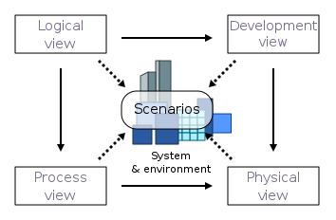

*Figure 1: 4+1 View Model of Architecture*

## 

## 

## 4.1 Scenarios View

In the scenarios view we cover various use cases that exist in the application. The entire system can be represented in a use case diagram that represents all the actions taken by different types of users. The scenarios’ view is related to the functional viewpoint, which represents the different actors and the actions they can perform within the context of the application.

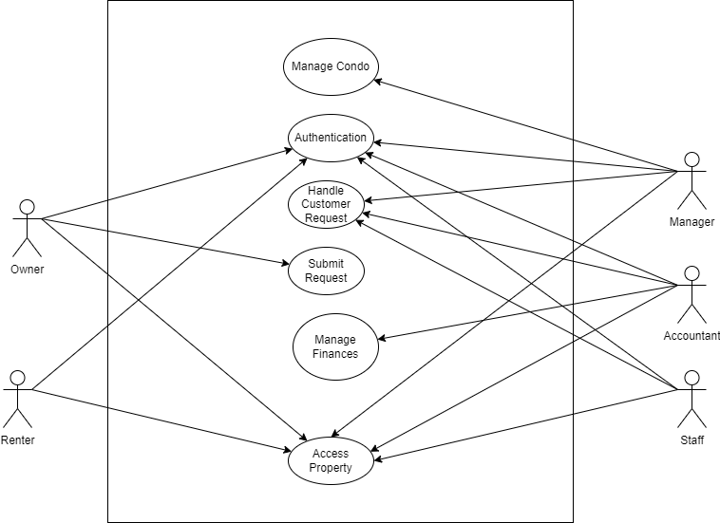

### 4.1.1 Use Cases Related to all Users

For the following uses cases the “User” is the public user (condo owner/renter), employees with different roles (including managers) and accountants. These users make use of all the functionalities in the application, some have different requirements than others. However, the following use cases relate to all of them.

* Authentication: All users of Condofy must be able to sign in to their accounts securely. Since all users have confidential data in their accounts, security is a main concern being addressed here. Recalling the security viewpoint, authentication has been included in our system design.
* Registration: All users must be able to sign up for Condofy or be signed up for the application, in the case of employees. Recalling the security viewpoint, registration has been included in our system design.

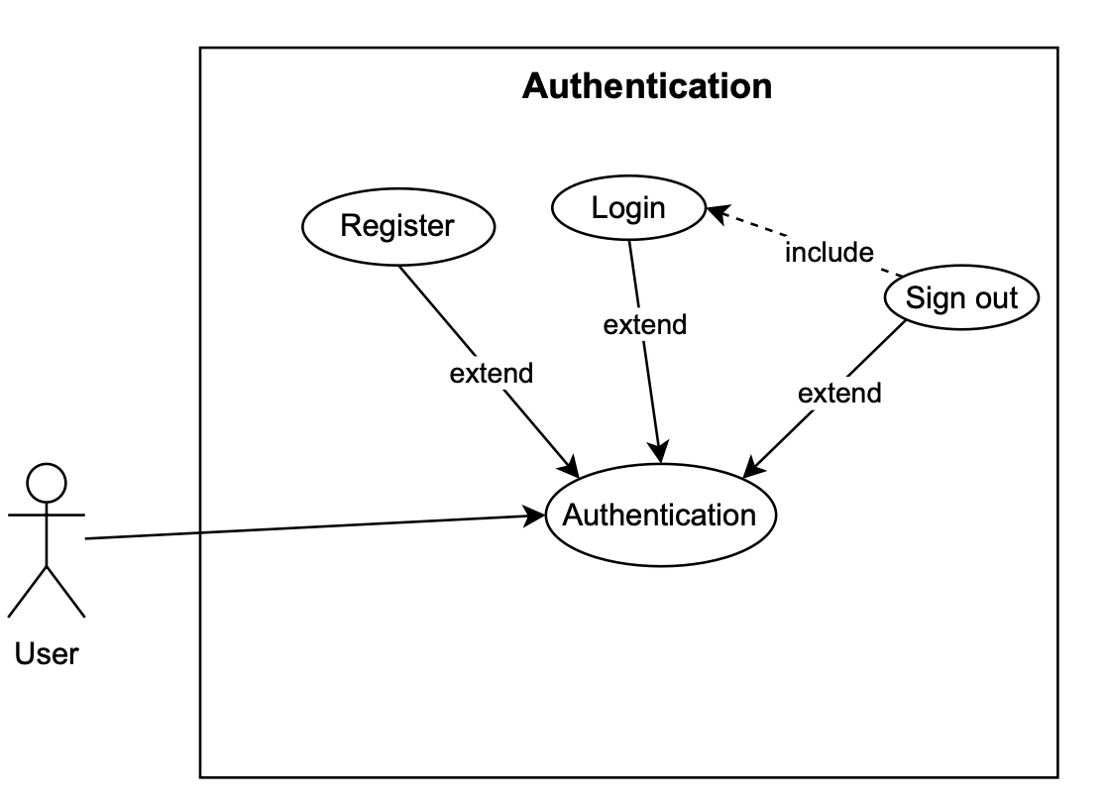

*Figure 2: Use Case Diagram for Authentication*

### 4.1.2 Use Cases Related to Owners

For these use cases “User” refers to a condo owner and “employee” refers to a user that works for a management company.

**User Request:** Users must be able to submit requests that have to be handled by an employee.

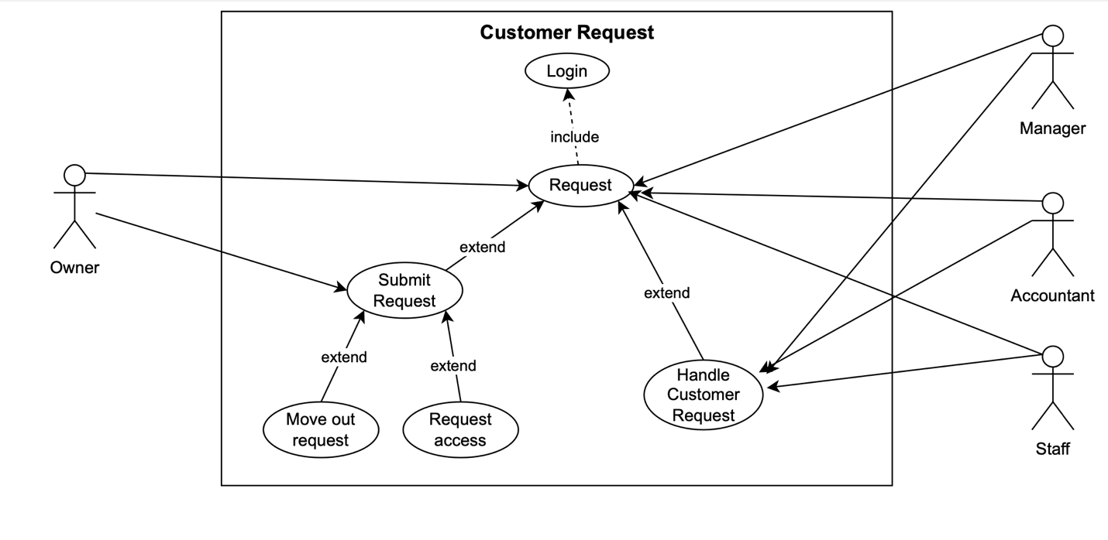

*Figure 3: Use Case Diagram for Customer Request*

**Access condo:** Users must be able to view their properties and their relevant information.

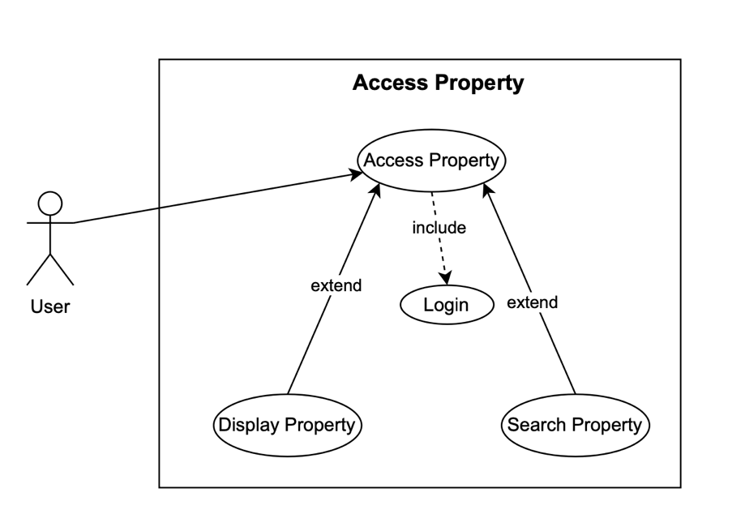

*Figure 4: Use Case Diagram for Access Property*

### 4.1.3 Use Cases Related to Managers

For these use cases “Manager” refers to a manager at a condo management company.

**Manage condos:** Managers must have access to delete, add and update condos. This information is confidential, and the data must not be accessible by anyone else, which represents the security viewpoint.

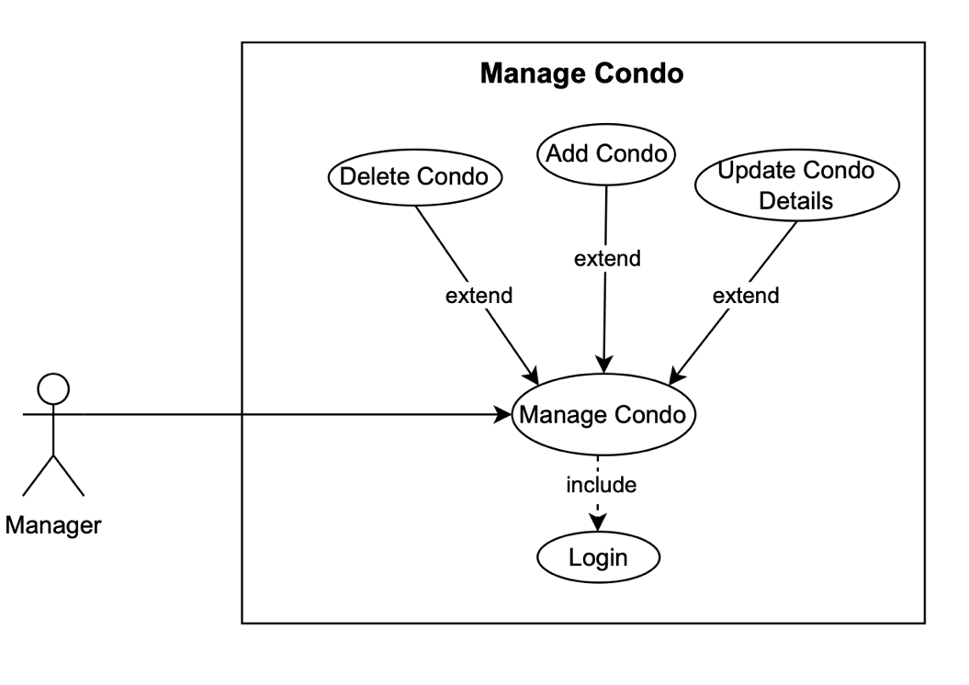

*Figure 5: Use Case Diagram for Managing Condo*

### 4.1.4 Knowns issue**s**

Various issues exist for the scenarios view:

**Incomplete**: Some scenarios lack important information due to the diagrams being very high level. For instance, the registration does not accurately represent how employees get registered differently than public users.

**Ambiguous**: Some scenarios could also be unclear for certain stakeholders, and instead of offering a bridge between development and stakeholders it could cause confusion.

## 4.2 Logical View

This view focuses on the functionalities of the system on a high level. The logical view represents all the components of the system. The development and information viewpoints are being represented here, as we focus on the flow of data between components and how components interact together.

The following component diagram represents the entire system.

### 4.2.1 Components

**Authentication Manager:** This component is responsible for handling all the requests relating to signing in, out and registering as any type of user. The authentication manager is also responsible for sending tokens that are going to be used in other components to ensure that the user has the correct privileges or is properly logged in.

**Account Management Component:** This component is responsible for handling all profiles and roles for all types of users.

**Condo Management Component:** This component is responsible for handling file uploading and the profiles for every condo.

**Request Management Component:** This component is responsible for handling the requests sent my owners. The component is also responsible for showing employees the requests and handling their responses.

**Dashboard Component:** This component is responsible for viewing the user’s profile and all their condos.

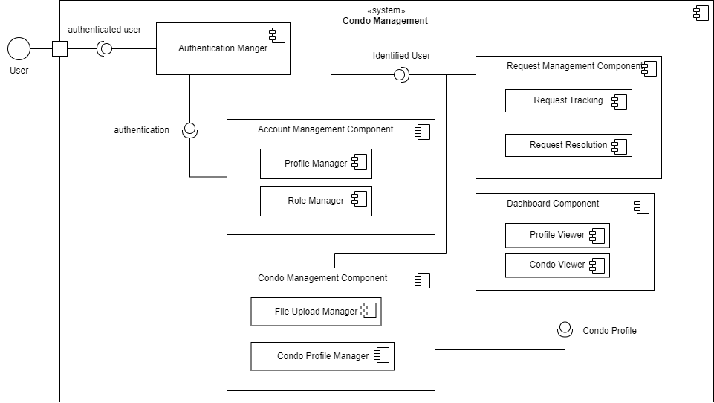

*Figure 6: Component Diagram*

### 4.2.2 Known issues

**Incomplete**: Component diagrams are high level and as such there is always some information that is not represented. For instance, the dashboard component should somehow show that different users will have different versions of this component. The UI will be different on the frontend and the backend handles different requests.

**No accurate division**: Component diagrams do not accurately represent how components are divided. For example, there is no clear division between what gets handled on the server side and what gets handled on the client side.

## 4.3 Process View

This view focuses on the processes performed by the system in run-time. Since this view focuses on concurrent task, we can see that it represents the concurrency viewpoint. The process view can be represented using an activity diagram, which shows the overall flow of different scenarios.

### 4.3.1 Activity diagram

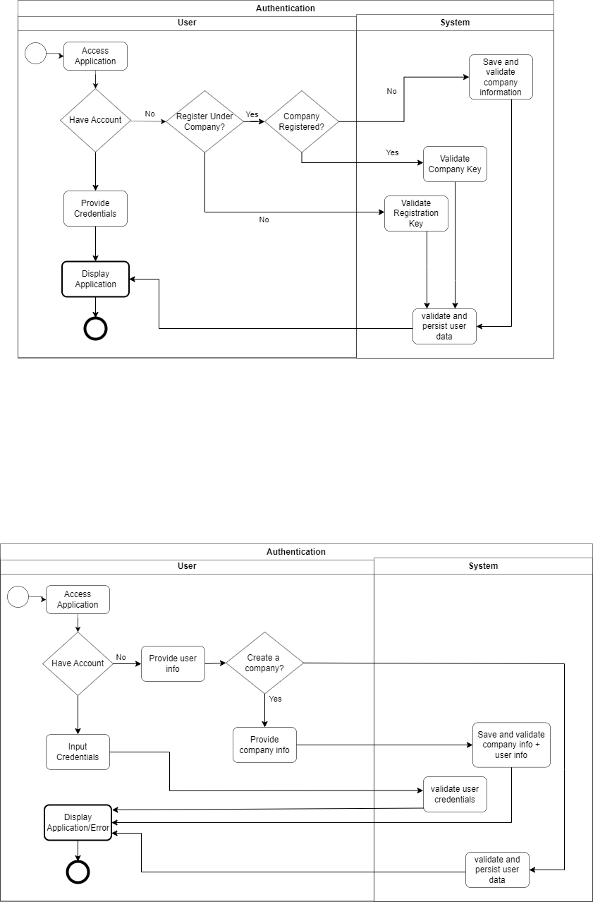

*Figure 7: Activity Diagram*

### 4.3.2 Known issues

**Unrealistic flow:** It is possible that sometimes the flow of a certain process is unrealistic and cannot be implemented the same way due to technical constraints.

**Complex**: Complex processes can lead to complex activity diagrams, which end up being confusing instead of helpful design tools.

## 4.4 Domain Model and Class Diagram

To develop a high-level understanding of the system, a domain model is used to represent entities and how they interact with one another. The class diagram gives a more detailed design for the system, showing attributes for entities and how they interact with one another.

Some important standard notations followed in this design:

* Arrows show visibility; where an arrow from A points to B implies A sees B. (e.g. Building has the id of the company it is managed by)
* * Means 0 to many multiplicity
* The domain model does not show attributes. The class diagram shows attributes.

The domain model identifies 3 main types of users, owners, renters, and employees. Employees (Staff, Accountant and Manager as defined in the Class Diagram) are linked to condo management companies. Renters are bound by contracts.

Companies are created by managers. During the signing up process of the first manager, they create a company. At this point the company is being managed by one manager, who can create other employees (including managers). This allows for better security and avoids having to send token to employees to join their company.

Owners and renters can only sign up when they have a registration key provided to them from the condo management company. The registration key is a key that connects the user’s profile to a unit. Essentially, a public user of the application should always be a renter or owner. This allows the system to be more secure, as it prevents non-residents and spammers from signing up to the website. The registration key also tells the system the role of the user, as the manager gives renters and owners different keys that can be recognized by the system. Employees have access to requests so they can address owners’ concerns.

The companies can manage many buildings (initially none) and each building has many storages, parking spots and units (initially none). The reason everything is initially defaulted to none is to allow the manager to fully customize the company and manage the properties as they see fit. The class diagram has unitCount, parkingCount, storageCount so that it can track how many assets a building has.

Buildings have facilities (Gym, Spa, and Sky lounge), which have many availabilities. Reservations have one availability taken each.

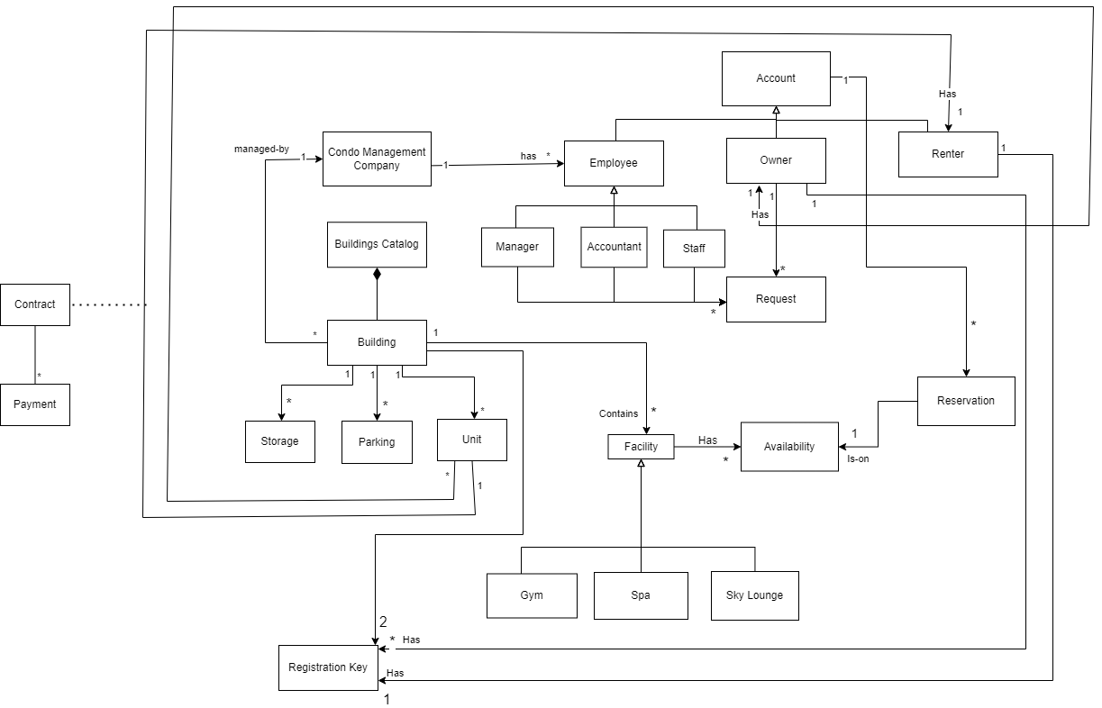

## 

## 4.5 Deployment View

This view is responsible for presenting the physical deployment of the application and the different nodes on which it exists and how they interact.

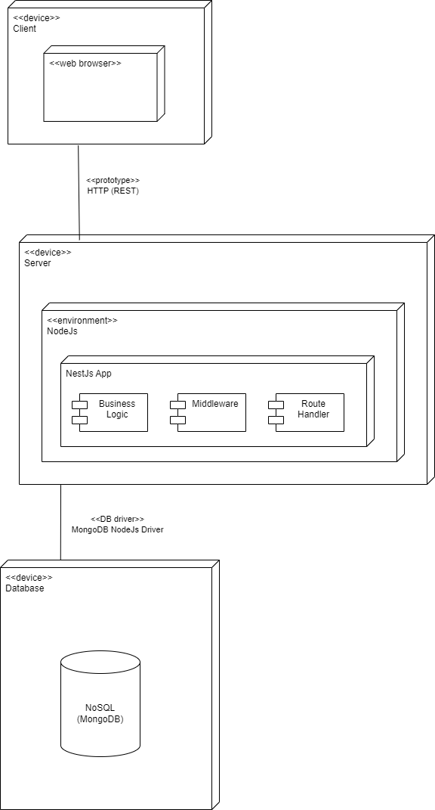

*Figure 10: Deployment Diagram*

## 

Condofy is a restful web application that serves dynamic content to clients, which primarily include web browsers on various devices capable of processing JavaScript. It operates on a robust server configured with the latest Node.js environment to manage high-volume data transactions and computational tasks efficiently.

The server, hosted in a centralized location with a dedicated network setup, is optimized for the application's operational demands without the immediate need for load balancing, given its current geographic and user-load constraints. The NestJS application on the server is meticulously structured with organized business logic, carefully selected middleware for authentication and logging, and efficient route handlers tailored for quick processing of HTTP requests and responses.

Direct interaction with the NoSQL database, MongoDB, is facilitated by the MongoDB Node.js Driver, allowing for agile development and flexible data schema modifications. The choice of a NoSQL database underpins the system's capacity for rapid scalability and cost-effective data management, ready to adapt to growing user demands.

The server architecture is designed with future growth in mind, allowing for seamless horizontal scaling by integrating additional servers as needed. Additionally, the system incorporates strategic data backup solutions to maintain data integrity and provides a framework for regular security updates and audits to safeguard against potential threats.

The server is hosted using onRender on <https://condofy.onrender.com/>, since the server is hosted using a free tier it needs poking to wake up from it’s idle state. The client side which hosts the actual app communicating with the backend is hosted using Vercel on <https://condo-management-client-ev87301tl-conodfys-projects.vercel.app/>.

### 4.5.2 Known issues

**Incomplete**: deployment view is very high level and as such omits details that could be used to certain architectures.

**No alignment with other diagrams**: the deployment diagram used for this view does not go with any other diagram used for the user views and so it’s difficult to see how it fits in.

# 5.Consistency and correspondences

As the software development industry continues to progress, a system's architecture serves as the fundamental framework for its present capabilities and future expansion. In this segment, we carefully examine the consistency requirements of Condofy, clearly stating any existing inconsistencies and outlining correspondences with precision. By doing so, we guarantee that the architecture description is precise, reliable, and consistent, all of which are essential for the successful development of the system.

## 5.1 Known inconsistencies

**Verification Process**

The absence of a verification process in the class diagram is a notable inconsistency, given the importance of this feature in the system's requirements. A verification process is critical to ensure that only authorized users, such as condo owners and renters, can access sensitive information and functionalities within the software. The class diagram should ideally reflect this process, possibly with a dedicated class or association that handles the verification logic, including the use of registration keys provided by the condo management company. This would typically involve classes or methods that validate the registration keys against the user profiles, linking them to their respective units, parking spots, or storage units. Without this explicit representation, the diagram lacks a clear depiction of a fundamental security feature, which could lead to ambiguity in the implementation phase and potential security vulnerabilities in the system.

**Employee Roles**

The class diagram's depiction of a generic "Employee" class presents an inconsistency by not differentiating between the specific roles of Manager, Accountant, and Staff as outlined in the system requirements. This lack of distinction is significant because each role likely has different permissions, responsibilities, and interactions with the system's features. For instance, an Accountant may need access to financial records and the ability to generate reports, whereas a Manager might require broader system access for overseeing operations. Without clearly defined classes for these roles in the diagram, developers may not implement the necessary role-based access control within the system, potentially leading to inadequate security measures and inefficient workflow management. This could result in unauthorized access to sensitive information and functions, compromising the system's integrity and operational efficiency.

**Request Assignment**

The class diagram's lack of a clear mechanism for assigning requests to specific employees based on the request type is a significant oversight. This functionality is crucial for ensuring that workflow within the condo management system is efficient and that requests are handled by the most qualified personnel. Without this, there could be confusion and delays in addressing requests, as well as a potential mismatch of tasks and employee expertise. The importance of this mechanism lies in its impact on service quality, response time, and overall user satisfaction, as well as the internal organization of the condo management company's operations. Implementing a clear assignment process in the system's design would enable a more streamlined, accurate, and accountable approach to managing and fulfilling user requests.

## 5.2 Correspondences in the AD

In the class diagram, there is a clear correspondence between the "Account" class and the "Owner" and "Renter" subclasses. This architectural relationship captures the essential link between a user account and the role it plays within the system. The rule here dictates that every account must be classified either as an owner or a renter, which is a crucial distinction for access control and feature availability within the system. This rule holds in the architecture description, as the connection is explicitly drawn, ensuring that user accounts are properly associated with their respective ownership or rental status.

The property management aspect of the system is well-represented through the relationship between the "Condo" class and the "Company" class, further branching into "Unit," "Parking," and "Storage" classes. The correspondence rule in this context ensures that each condo is managed by the company and is linked to its constituent units and amenities, which is clearly maintained in the architecture description. This ensures that the condo management company has the necessary oversight and data organization structure to manage property details effectively.

As observed in the class diagram, the "Condo" and "Account" linkage through the "Owner" subclass establishes a direct relationship between the property and its owner, reflecting the ownership status within the system. The correspondence rule here mandates that every condo must be associated with an owner account, and this rule is observed in the architecture description, providing a reliable reference for ownership details and related functionalities. However, to align with financial transaction requirements, it would be prudent to integrate financial attributes directly into this relationship, enhancing the system's financial tracking capabilities.

# **Risk Assessment and Management Plan (RMP)**

# Introduction

The Risk Assessment and Management Plan (RMP) is designed to identify and address potential risks that could affect our project's progression negatively. By identifying risks based on user stories, assessing their likelihood and severity, and implementing appropriate mitigation strategies, we aim to minimize their impact as much as possible.

# Understanding used Metrics

It is vital to understand how we define a risk and how we quantify it. For instance,we define risk as any event that might disrupt team efficiency, particularly regarding manpower.. By this, we mean that anything that may pose a nuisance to the entirety of the team is considered a risk. Given that manpower can be disrupted in several ways, we have identified and categorized types of risks below:

* Technical Risks: Include issues related to technology performance, security, and compatibility.
* Organizational Risks: Encompass challenges related to resources, budget management, scheduling, and communication.

Upon understanding the type of risk we deal with, analyzing the risk is the next step. For this, there are two metrics to consider: probability and impact.

* Probability: Assessed as low, medium, or high based on past experiences and patterns in software development projects.
* Impact: Evaluated based on its effect on performance, schedule, and cost, with severity rated as low, medium, or high. We have disclosed that an impact of a risk can be affected in 3 ways:
  + Performance: technical, personal experience, documentation
  + Schedule: delays, task dependencies, inadequate times estimates for tasks
  + Cost: respecting budget

In order to quantify impact, we take several factors into consideration, and we scaled the level of impact a risk has based on the ratings below:

* + **Low**: has no effect on the user, can be reversed quickly, is part of the process (e.g. redesigning)
  + **Medium**: needs reworking, leads to poor app performance (e.g. slow loading times)
  + **High**: Blocks other user stories/tasks, needs a lot of reworking, leads to data loss, leads to security breach.

The probability and the impact of a risk can be identified through the usage of a risk matrix as we have done so in Section 4.

# Risk Assessment and Management Plan

Given that we have identified 2 types of risks that can affect manpower, our focus on risk assessment and mitigation will be put on those as follows.

Regarding technical risks, problems such as compatibility issues, scalability challenges and data breaches are all possible. Acknowledging these risks as well as being able to mitigate them is vital in RMP. For instance, to overcome such technical risks once apparent, regular maintenance and updates to the application will address vulnerabilities and improve performance. In addition, implementing security measures such as encryption, firewalls and access controls will help protect against unwarranted access. Thorough testing throughout will also help in mitigating technical risks before deployment.

Regarding organizational risks, it’s important to recognize and consider issues such as key personnel dependency and competing priorities. To mitigate organizational risks, establishing clear channels of communication, fostering engagement amongst all team members, diversification of dependencies and resource planning are all crucial mitigations to ensure alignment with the project objectives and minimization of organizational risks.

As such, depending on the type of risk, be it technical or organizational, the according mitigation plans are set in place to ensure that risks are well considered for resolution.

Regardless of the type of manpower encountered, both will follow the same risk assessment plan. This can be broken down into 5 steps as follows:

1. **Risk Identification:** The purpose of risk identification is to create a list of potential risks, covering a range of categories. By identifying risks early on, we can proactively address them and minimize them.
2. **Risk Analysis:** The purpose of risk analysis is to calculate the risk exposure for each risk. That is, we analyze the probability of each risk occurring and estimate its impact, all of which are based on the way we quantified both probability and impact.
3. **Risk Prioritization:** The purpose of risk prioritization is to consider the results gathered from analysis and to prioritize the risks according to their risk exposure (probability and impact). Prioritizing risks allows us to focus our efforts and resources on addressing the most critical threats.
4. **Risk Planning and Resolution:** The purpose of risk planning is to identify appropriate risk responses such as avoidance, mitigation, acceptance, or transfer and to implement such strategies. Risk planning ensures that we are quipped to respond effectively to adverse events and minimize their impact throughout the course of the project.
5. **Risk Monitoring:** The purpose of risk monitoring is to keep track of risk changes and assessing the effectiveness of risk management activities defined in the previous step. Risk monitoring involves communicating risk status to relevant stakeholders and enables us to adapt to ongoing threats.

# Risk Matrix

The categorization of user stories can be represented on a table:

| Impact  Probability | Low | Medium | High |
| --- | --- | --- | --- |
| Low | CN-25, CN-130, CN-162 | CN-37, CN-32, CN-57, CN-56, CN-55, CN-139, CN-156 | CN-2, CN-15, CN-31, CN-66, CN-67, CN-132, CN-139, CN-129, CN-160, CN-158, CN-153, CN-180, CN-154, CN-159, CN-161 |
| Medium | CN-149 | CN-29, CN-53, CN-128, CN-157 | CN-97, CN-151 |
| High | CN-87, CN-59, CN-163, CN-164 |  | CN-65 |

| Risk ID | Risk Type and Description | Risk Score | Resolved in Sprint | Strategy and Effectiveness |
| --- | --- | --- | --- | --- |
| CN-2 | Technical: Inadequate security measures can lead to data leaks | * Probability: Low * Impact: High * Overall: Medium | 1 | Avoid: Incorporate secure measures against security threats (HTTPS, input validation) |
| CN-15 | Technical: Unprotected routes in backend can lead unauthorized access | * Probability: Low * Impact: High * Overall: Medium | 1 | Avoid: Implement route protection mechanisms and regularly review its configurations |
| CN-37 | Technical: Inefficient handling of storage of profile pictures can lead to performance issues | * Probability: Low * Impact: Medium * Overall: Low | 1 | Mitigate: Implement optimized storage solutions for profile pictures |
| CN-29 | Organizational (Schedule): Ambiguous activity diagrams may result in delays due to workflow misunderstanding | * Probability:Medium * Impact: Medium * Overall: Medium | 1 | Mitigate: Collaborate with all team members to ensure everyone agrees on a consistent design that fits the overall requirements |
| CN-25 | Organizational (Schedule): Poorly designed component diagrams can lead to delays due to  misunderstanding the system architecture | * Probability: Low * Impact: Low * Overall: Low | 1 | Accept: Later design choices related to component diagrams will result in minimal cons as component driven features can always be updated internally. |
| CN-32 | Organizational (Management): Unclear vision in product statement can lead to misalignment among team members | * Probability: Low * Impact: Medium * Overall: Low | 1 | Avoid: Given that a baseline already exists in terms of the product vision, misinterpretations can easily be avoided through communication effectively as a team |
| CN-31 | Technical: Inadequate security measures could allow a user to falsely modify another user’s profile info. | * Probability: Low * Impact: Hight * Overall: Medium | 2 | Avoid: Ensure that only logged in users with valid token can modify their own profile |
| CN-53 | Technical: If a manager has many properties to manage, inadequate displaying of the properties may lead to incorrect managing | * Probability: Medium * Impact: Medium * Overall: Medium | 2 | Avoid: User a general Data Table component that can handle a lot of information and many actions. |
| CN-67 | Technical: Unprotected routes in backend can lead to unauthorized access | * Probability: Low * Impact: High * Overall: Medium | 2 | Avoid: Implement route protection mechanisms and regularly review its configurations |
| CN-55 | Design: In-adherence to the design could lead to submitting incorrect information to the form and corrupt the database. | * Probability: Low * Impact: Medium * Overall: low | 2 | Avoid: Adhere to the UX designs and follow the class diagram to ensure all the necessary data are passed. |
| CN-56 | Design: In-adherence to the design could lead to submitting incorrect information to the form and corrupt the database. | * Probability: Low * Impact: Medium * Overall: low | 2 | Avoid: Adhere to the UX designs and follow the class diagram to ensure all the necessary data are passed. |
| CN-57 | Design: In-adherence to the design could lead to submitting incorrect information to the form and corrupt the database. | * Probability: Low * Impact: Medium * Overall: low | 2 | Avoid: Adhere to the UX designs and follow the class diagram to ensure all the necessary data are passed. |
| CN-65 | Organizational (Schedule): Due to the complexity of the user story, it is a blocker for other user stories (CN-66 and CN-67). Delays in this user story delay the entire project | * Probability: High * Impact: High * Overall: High | 2 | Mitigation: divide the story down into smaller tasks that can be done simultaneously and divide them among members to ensure faster development |
| CN-66 | Technical: Unprotected routes in backend can lead to unauthorized access | * Probability: Low * Impact: High * Overall: Medium | 2 | Avoid: Implement route protection mechanisms and regularly review its configurations |
| CN-97 | Organizational (Schedule): Since this is the first main user story for the mobile app, delays in would leave to delays in subsequent stories. | * Probability: Medium * Impact: High * Overall: High | 2 | Mitigate: Divide the user story on multiple subtasks that could lead to smoother development. |
| CN-132 | Technical: Since we now deal with financial data, data breaches and unauthorized access are a lot more concerning | * Probability: Low * Impact: High * Overall: Medium | 3 | Avoid: Ensure proper security measures are in place to promote secure financial measures |
| CN-130 | Technical: If the backend calculations are not done correctly, this can lead to inaccurate estimates for parking price | * Probability: Low * Impact: Low * Overall: Low | 3 | Avoid: Ensure adequate testing measures are in place to generate accurate parking fees |
| CN-128 | Design: Given that there is a lot more data involved with the property financial management, user interface design may be inconsistent with all other designs, leading to a poor user experience for employees | * Probability: Medium * Impact: Medium * Overall: Medium | 3 | Mitigate: Reference other Figma designs from other pages to ensure adequate consistency in terms of UI. |
| CN-139 | Technical: a large number of condos belonging to an owner may lead to scalability issues, causing performance degradations | * Probability: Low * Impact: High * Overall: Medium | 3 | Avoid: Ensure frontend system follows modern procedures form a service standpoint so that all condos can be shown on screen. |
| CN-149 | Design: Discrepancies in UI design between the web and mobile app can result difficult mobile implementation | * Probability: Medium * Impact: Low * Overall: Low | 3 | Accept: Different designs from the mobile and web app are to be expected. To ensure seamless mobile development, accurate Figma design should be well referenced. |
| CN-87 | Technical: Inexperience in mobile development leads to difficulties in carrying out the task | * Probability: High * Impact: Low * Overall: Medium | 3 | Accept: Ensure that Mobile developers first learn the basics and how it differs from web development. |
| CN-129 | Technical: Poor handling in the backend can result in retrieving employees that may not belong to an owner’s company. | * Probability: Low * Impact: High * Overall: Medium | 3 | Avoid: Use multiple test cases to ensure backend logic is consistent with the feature’s requirements. |
| CN-139 | Technical: Inexperience in creating pdf downloadable files leads to difficulties in carrying out the task | * Probability: Low * Impact: Medium * Overall: Low | 4 | Migitate: Make use of a 3rd party library that handles the pdf generation |
| CN-156 | Design: In-adherence to the design could lead to submitting incorrect information to the form and corrupt the database. | * Probability: Low * Impact: Medium * Overall: low | 4 | Avoid: Adhere to the UX designs and follow the class diagram to ensure all the necessary data are passed. |
| CN-157 | Technical: Displaying real-time notifications requires usage of web-sockets or similar techniques that need experience, and time to set up. Inexperience could lead tod difficulties in carrying out the task. | * Probability: Medium * Impact: Medium * Overall: Medium | 4 | Mitigation: Use a 3rd party software that abstracts the difficulties and provides a UI, and connects to the backend and frontend as a real-time port. |
| CN-151 | Organizational: This ticket is a blocker for other tickets. Facilities need to be created before reservations and availabilities related tasks are done. Delays in this task could delay the entire sprint. | * Probability:Medium * Impact: High * Overall: High | 4 | Avoid: Start this task as soon as possible to avoid delays. |
| CN-160 | Technical: Difficulties in handling dates in JS could lead to incorrectly displayed dates, and create wrote availabilities | * Probability: Low * Impact: High * Overall: Medium | 4 | Avoid: properly testing the UI ensures that all dates and UI is as expected. |
| CN-158 | Technical: incorrectly displaying owner-only information to tenants may lead to a privacy breach | * Probability: Low * Impact: High * Overall: Medium | 4 | Avoid: only receive tenant-relevant information from the backend and display the relevant info. |
| CN-153 | Organizational (schedule): This backend task must be completed before any of the related UI can be complete. Any delays here can lead to further delays. | * Probability: Low * Impact: High * Overall: Medium | 4 | Avoid: Start this task as soon as possible to avoid delays. Divide the task into multiple PRs and subtasks to allow for concurrent backend and frontend development |
| CN-180 | Technical: Difficulties in handling dates in JS could lead to incorrectly reserved times and inconsistencies between the backend and frontend. | * Probability: Low * Impact: High * Overall: Medium | 4 | Avoid: properly testing the UI ensures that all dates and UI is as expected. |
| CN-162 | Design: Failure to adhere to the designs set by UX could lead to a poor user experience | * Probability: Low * Impact: Low * Overall: Low | 4 | Avoid: Follow the UI designs and communicate with other frontend developers. |
| CN-154 | Technical: Failure to properly map requests to the correct employees could lead to security issues and requests not being resolved | * Probability: Low * Impact: High * Overall: Medium | 4 | Avoid: Implement proper unit tests and always test new endpoints |
| CN-59 | Organizational: Inexperience in mobile development can lead to delays in completion of the task. | * Probability: High * Impact: Low * Overall: Medium | 4 | Accept: Learn mobile development and accept the learning curve |
| CN-163 | Organizational: Inexperience in mobile development can lead to delays in completion of the task. | * Probability: High * Impact: Low * Overall: Medium | 4 | Accept: Learn mobile development and accept the learning curve |
| CN-164 | Organizational: Inexperience in mobile development can lead to delays in completion of the task. | * Probability: High * Impact: Low * Overall: Medium | 4 | Accept: Learn mobile development and accept the learning curve |
| CN-159 | Tehcnical: incorrectly displaying the available parkings and storages may lead to a manager incorrectly unassigning a parking or storage from a unit. | * Probability: Low * Impact: High * Overall: Medium | 4 | Migitation: the backend validates this and will ensure the manager doesn’t unassign parkings and storages through the same request as updating |
| CN-161 | Technical: Failure to properly map requests to the correct employees could lead to security issues and requests not being resolved | * Probability: Low * Impact: High * Overall: Medium | 4 | Avoid: test the UI for all types of employees and the manager |

# **Testings**

As part of requirements for each sprint, unit tests were implemented for all services and controllers in the backend. Running a small script “pnpm run test:cov” allows us to run the tests with coverage.

## Sprint 2

For sprint 1, coverage comes to 61.9% because more functionalities than required for the sprint have been implemented but still untested.

Below is a screenshot of the coverage, as generated by the package.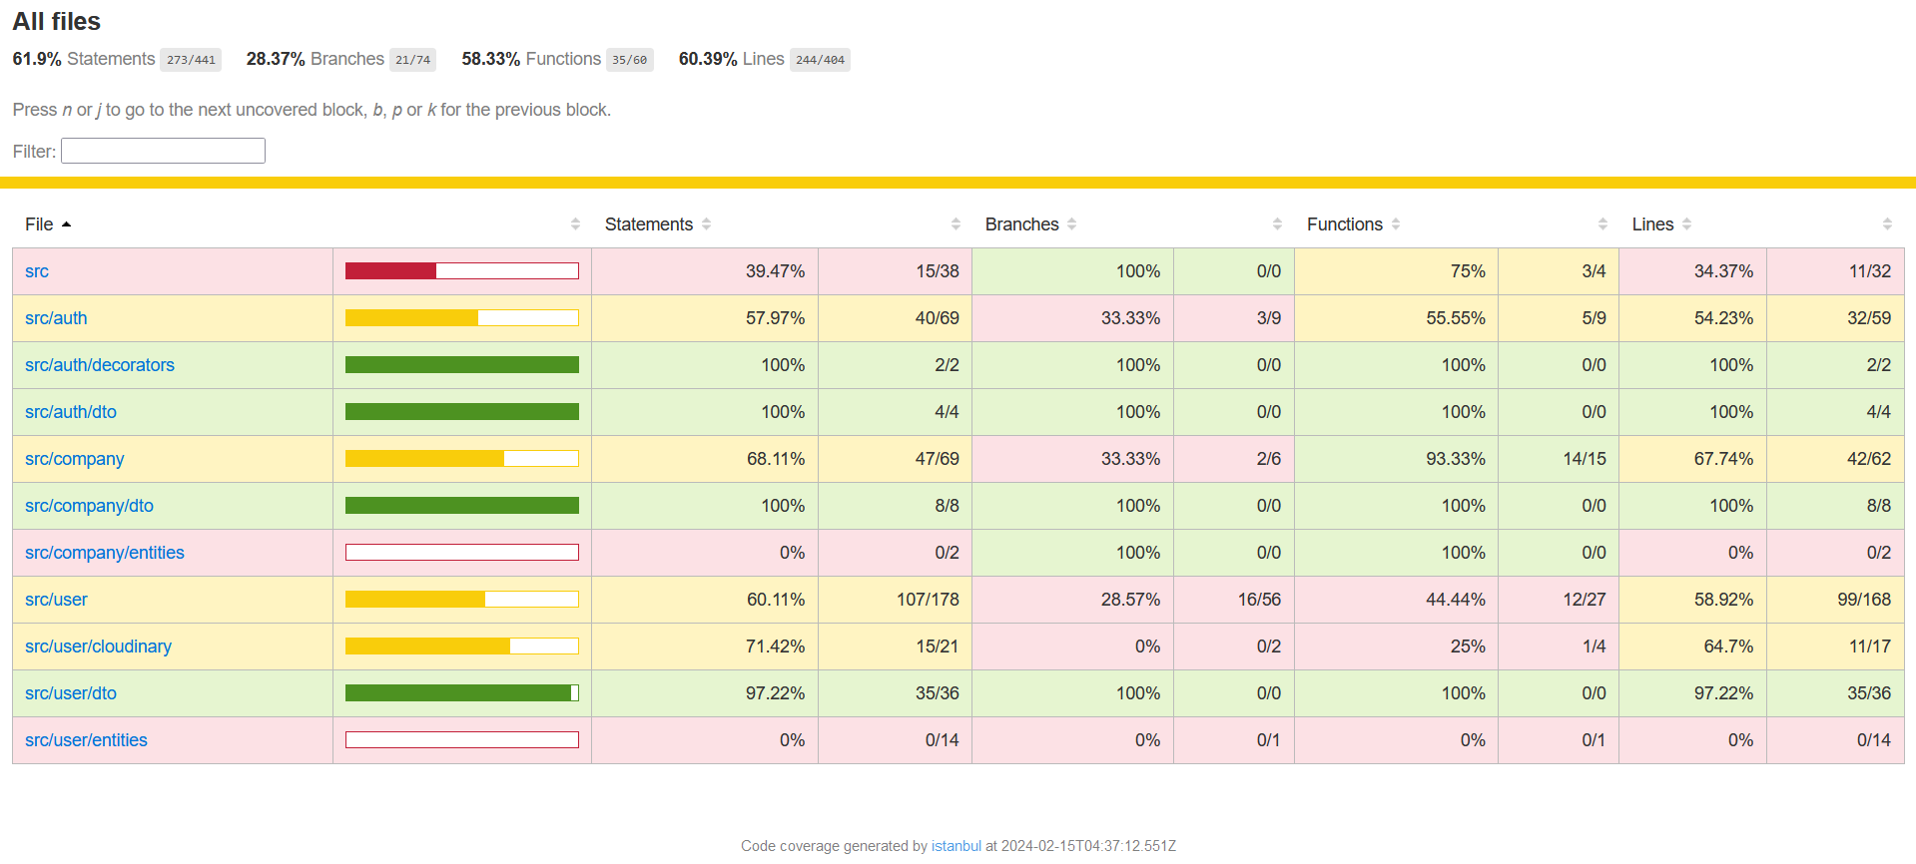

## Sprint 3

Below is a screenshot of the coverage, as generated by the package, with 84.9% coverage.

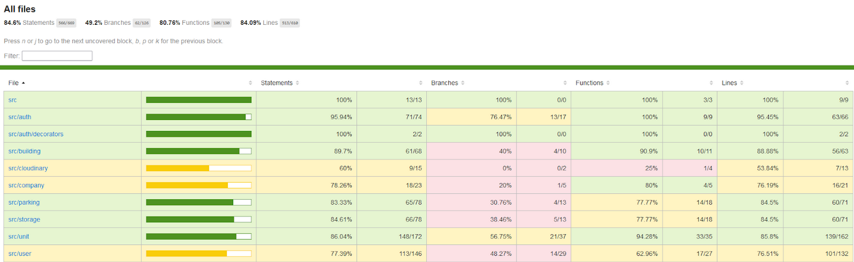

## Sprint 4

As part of the requirements for sprint 4, integration tests were introduced. Running the small script “pnpm run test:e2e” displays the testing results. Below is a screenshot of the first integration test that “creates a manager”.

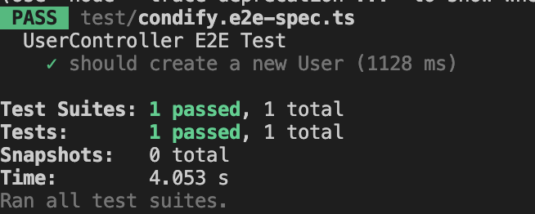

Below is a screenshot of the coverage, as generated by the package, with 85.34% coverage.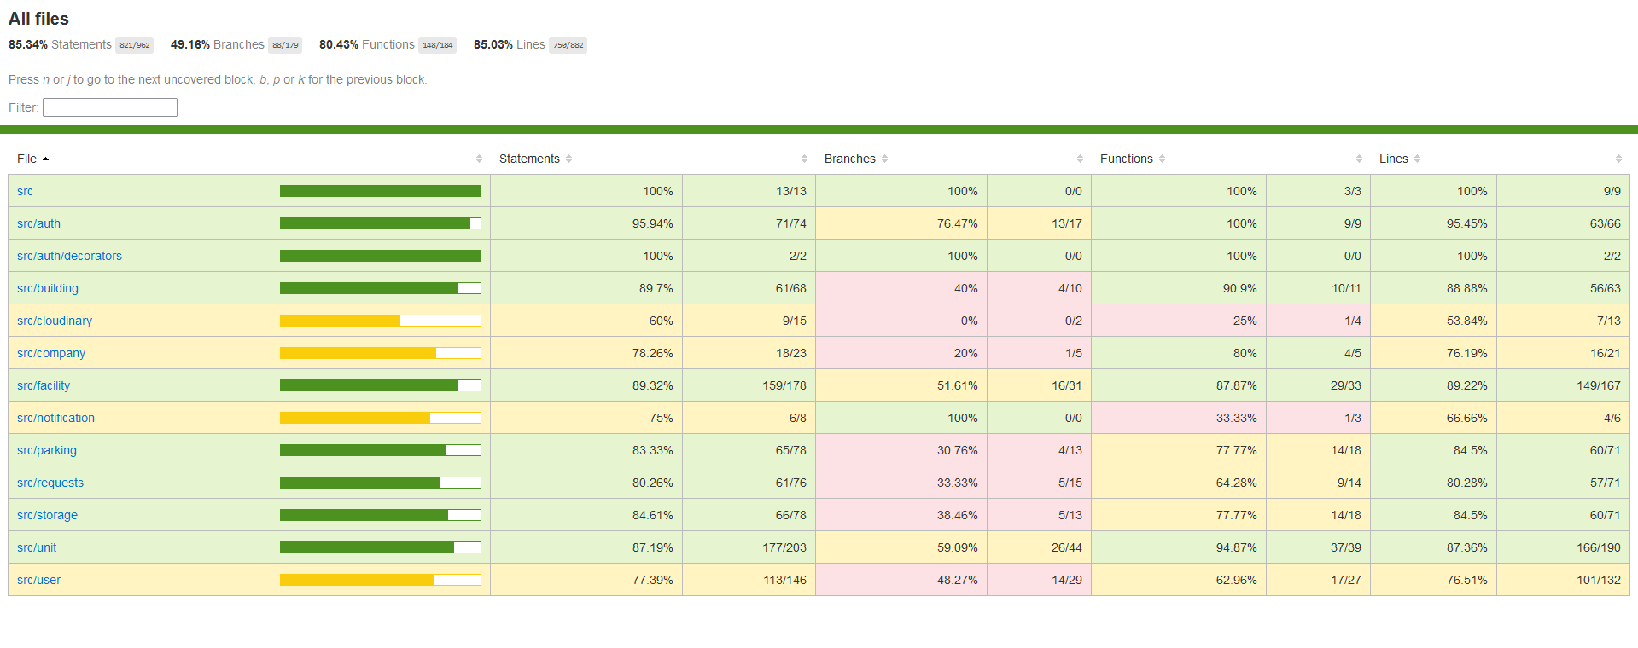

# **Sprint Retrospectives**

# Introduction

In this postmortem, we reflect on our journey of developing a web application aimed at simplifying condo management. Our team embarked on this project with high hopes, aiming to leverage modern technology to address the complexities of condo management. Utilizing a range of tools and architectural practices, we aimed to create a robust solution that meets the diverse needs of condo managers and residents alike. Despite facing challenges along the way, we are happy with what we have achieved and the lessons we have learned.

## Sprint 2

**What went wrong?**

1. Time Management Struggles:Our team faced significant challenges in coordinating schedules among our ten members, leading to difficulties in holding comprehensive meetings. This misalignment impacted our project timeline and overall efficiency.
2. Task Distribution:Fairly dividing tasks among team members proved to be a complex undertaking. Ensuring that each member was assigned tasks that matched their skill set and workload expectations required continuous adjustment and led to some inefficiencies.
3. Code Compatibility Issues:We encountered compatibility problems when merging code, which led to delays and additional debugging efforts. These issues highlighted the need for a more robust version control strategy.
4. Lack of Clear Product Vision:Initially, our team struggled with a clear and unified vision for the product. This ambiguity led to misaligned efforts and revisions in the project's early phases.
5. Underestimation of Task Complexity:Several tasks were underestimated in terms of complexity and time requirements, leading to delays and the need for additional resources.

**What went right**

1. Effective Communication:Despite the challenges, our team maintained a strong emphasis on communication. Members were supportive, frequently stepping in to assist with tasks outside their assigned responsibilities, fostering a collaborative team environment.
2. Adherence to Agile Methodologies:Our commitment to agile practices allowed us to adapt quickly to changes and feedback, ensuring continuous improvement in our development process.
3. Effective Use of Tools: Utilizing collaboration and project management tools effectively helped in keeping the team organized and on track, despite remote working conditions.
4. High-Quality Code Standards:The team maintained high standards of code quality through peer reviews and adopting best coding practices, which significantly reduced bugs in the final product.
5. Successful Stakeholder Engagement:Regular updates and feedback sessions with the user ensured that the project remained aligned with user needs and expectations.

**Conclusion**

This sprint taught us valuable lessons in time management, task distribution, and the importance of effective communication. Moving forward, we aim to prioritize critical tasks and assign them based on team members' expertise, ensuring a more streamlined and efficient workflow.

## Sprint 3

**What went wrong?**

1. Domain Model Refactoring: The need to refactor our domain model multiple times presented considerable challenges:

* Each refactoring necessitated widespread changes across the codebase, increasing the risk of introducing bugs.
* It diverted resources away from feature development and bug fixes, affecting our overall project timeline.
* Adapting to changing requirements while maintaining code quality and project momentum required careful management and additional testing cycles.

1. Backend Complexity vs. Frontend Test Coverage: The advanced complexity of the backend compared to the frontend presented unique challenges, particularly in achieving our goal of 80% test coverage. The sophisticated logic and data handling required in the backend made it difficult to ensure comprehensive testing, highlighting a need for enhanced strategies in test planning and execution.
2. Challenges with Mobile App Development: Different Styling Requirements: The mobile app required a distinct approach to styling compared to the web version. The need to adapt layouts, fonts, and interaction elements for smaller screens introduced complexities that were not initially anticipated.

**What went right?**

1. Effective Communication: Despite the challenges, our team maintained a strong emphasis on communication. Members were supportive, frequently stepping in to assist with tasks outside their assigned responsibilities, fostering a collaborative team environment.
2. Completion of All Planned User Stories: A significant achievement for our team was the ability to complete all user stories planned for the sprint without needing to push any to the next sprint. This success demonstrates our effective planning, estimation, and execution capabilities, ensuring that we met our project goals within the set timeframe.
3. Adherence to Agile Methodologies:Our commitment to agile practices allowed us to adapt quickly to changes and feedback, ensuring continuous improvement in our development process.
4. Effective Use of Tools:Utilizing collaboration and project management tools effectively helped in keeping the team organized and on track, despite remote working conditions.
5. High-Quality Code Standards:The team maintained high standards of code quality through peer reviews and adopting best coding practices, which significantly reduced bugs in the final product.
6. Successful Stakeholder Engagement:Regular updates and feedback sessions with the user ensured that the project remained aligned with user needs and expectations.

**Conclusion**

In this sprint, we navigated through challenges such as multiple domain model refactoring, achieving test coverage due to backend complexity and complexity for mobile app development. Despite these, our strengths in communication, completing all planned user stories, adhering to agile methodologies, utilizing tools effectively, maintaining high code quality, and engaging stakeholders played a pivotal role in our success.

## Sprint 4

**What went wrong?**

1. Challenges with Mobile App Development: Different Styling Requirements: The mobile app required a distinct approach to styling compared to the web version. The need to adapt layouts, fonts, and interaction elements for smaller screens introduced complexities that were not initially anticipated.

**What went right?**

1. Effective Communication:Despite the challenges, our team maintained a strong emphasis on communication. Members were supportive, frequently stepping in to assist with tasks outside their assigned responsibilities, fostering a collaborative team environment.
2. Completion of All Planned User Stories:A significant achievement for our team was the ability to complete all user stories planned for the sprint without needing to push any to the next sprint. This success demonstrates our effective planning, estimation, and execution capabilities, ensuring that we met our project goals within the set timeframe.
3. Adherence to Agile Methodologies:Our commitment to agile practices allowed us to adapt quickly to changes and feedback, ensuring continuous improvement in our development process.
4. Effective Use of Tools:Utilizing collaboration and project management tools effectively helped in keeping the team organized and on track, despite remote working conditions.
5. High-Quality Code Standards:The team maintained high standards of code quality through peer reviews and adopting best coding practices, which significantly reduced bugs in the final product.
6. Successful Stakeholder Engagement:Regular updates and feedback sessions with the user ensured that the project remained aligned with user needs and expectations.

**Conclusion**

In this sprint, we only navigated through one challenge which was the complexity for mobile app development. Our strengths in communication, completing all planned user stories, adhering to agile methodologies, utilizing tools effectively, maintaining high code quality, and engaging stakeholders played a pivotal role in our success.

# **Release Plan**

## Deployment:

The frontend app and the backend app have been deployed separately. Vercel is Frontend Cloud deployment provider which allows us to host the app and continuously redeploys, and checks for deployment on every PR. Render, another cloud deployment provider, hosts the server side. The frontend application communciates with the server-side via REST requests. Also, continuously redeploys and checks for deployment on every PR.

Moreover, on every PR we rebuild the apps, and deploy (CI/CD). The application is fully deployed with a stable production built on every merge to the main branch.

| **User Story ID** | **User Story Points**  **(USP)** | **Priority** | **Status** |
| --- | --- | --- | --- |
| Sprint 1 |  |  |  |
| Frontend - User sign-in | 3 | High | DONE |
| Frontend - User Registration | 3 | High | TODO |
| Frontend - Company registration | 3 | High | DONE |
| Backend - User Registration | 5 | High | TODO |
| Backend - User Sign-in | 5 | High | TODO |
| Backend - Implement endpoint for managing user information | 3 | Medium | TODO |
| Frontend - User Profile page | 3 | Medium | PUSHED TO  SPRINT #2 |
| Product vision statement document | 2 | High | DONE |
| Testing Plan | - | High | DONE |
| Risk assessment and Risk Management Plan (RMP) | 2 | High | DONE |
| SAD - Deployment Diagram | 2 | High | DONE |
| SAD - Start the Activity Diagram | 2 | High | DONE |
| SAD - Domain Model (focused on Authentication) | 2 | High | DONE |
| SAD - Start Use Case Diagram | 2 | High | DONE |
| Backend - non-existent users can sign in | 1 | High | DONE |
| SAD - Component Diagram | 2 | High | DONE |
| SAD - Class Diagram (sprint 1) | 2 | High | DONE |
| Frontend - Company registration | 3 | High | DONE |
| **Total USP** | 45 |  |  |

| Sprint 2 |  |  |  |
| --- | --- | --- | --- |
| Frontend - User profile page | 3 | High | DONE |
| Frontend - Property Dashboard (Company) | 3 | High | DONE |
| Frontend - Create Unit Dashboard Page for parent Building | 3 | High | DONE |
| Frontend - Create property/Building Page | 3 | High | DONE |
| Frontend - Create Unit Page | 3 | High | DONE |
| Backend - Condo Management | 4 | High | DONE |
| Backend - Condo registration | 3 | High | DONE |
| Backend - Parking & Storage | 3 | High | DONE |
| **Total USP** | 32 |  |  |

| Sprint 3 |  |  |  |
| --- | --- | --- | --- |
| Frontend - Manage Employees Page | 3 | Medium | DONE |
| Frontend - Wire up Edit assets | 1 | High | DONE |
| Frontend - Create Employee Page (Web & Mobile) | 5 | High | DONE |
| Frontend - Update Navbar | 3 | Medium | DONE |
| Mobile - Sign Up | 3 | Medium | DONE |
| Mobile - User Profile Page | 2 | Medium | DONE |
| Mobile - Maintain Authentication | 3 | Medium | DONE |
| Frontend - Public User Dashboard (Units, Personal info | 4 | High | DONE |
| Frontend - Manage unit financial status (Company) | 3 | High | DONE |
| Frontend- Owner view Financial Report | 3 | High | PUSHED TO SPRINT #4 |
| Backend - Get Company Employees | 2 | High | DONE |
| Backend - Parking Price Calculation | 4 | High | DONE |
| Backend - Owner Financial Status | 3 | High | DONE |
| Backend - Manage a unit’s Financial Status | 4 | High | DONE |
| **Total USP** | 42 |  |  |

| Sprint 4 |  |  |  |
| --- | --- | --- | --- |
| Backend- Manage Facilities (Company) | 3 | High | DONE |
| Backend- Make Reservations (Public users) | 3 | High | DONE |
| Backend- Handle requests (Comapny) | 3 | High | DONE |
| Backend- Submit requests (Owner) | 3 | High | DONE |
| Backend- Dispatch Notifications | 4 | High | DONE |
| Frontend- Owner view Financial Report | 3 | High | MOVED FROM SPRINT #3 |
| Frontend- Renter view unit | 2 | Medium | DONE |
| Frontend - Link parking/storage to unit | 2 | High | DONE |
| Frontend- Company manages facilities | 4 | High | DONE |
| Frontend- Employees handle requests | 4 | High | DONE |
| Frontend- Owners submit requests | 4 | High | DONE |
| Frontend- Owner dashboard (mobile) | 3 | Medium | REMOVE |
| Frontend- Manage employees (mobile) | 3 | Medium | REMOVE |
| **Total USP** | 41 |  |  |

## Sprint 5

There will be no user stories for sprint 5, all the requested requirements have been met. Sprint 5 will be reserved for refactoring and bug fixing.

# **UI Prototypes – User Stories**

**User Story for Registration:**

US-1: As a potential new user, I want to register for an account so that I can manage my condo-related tasks.

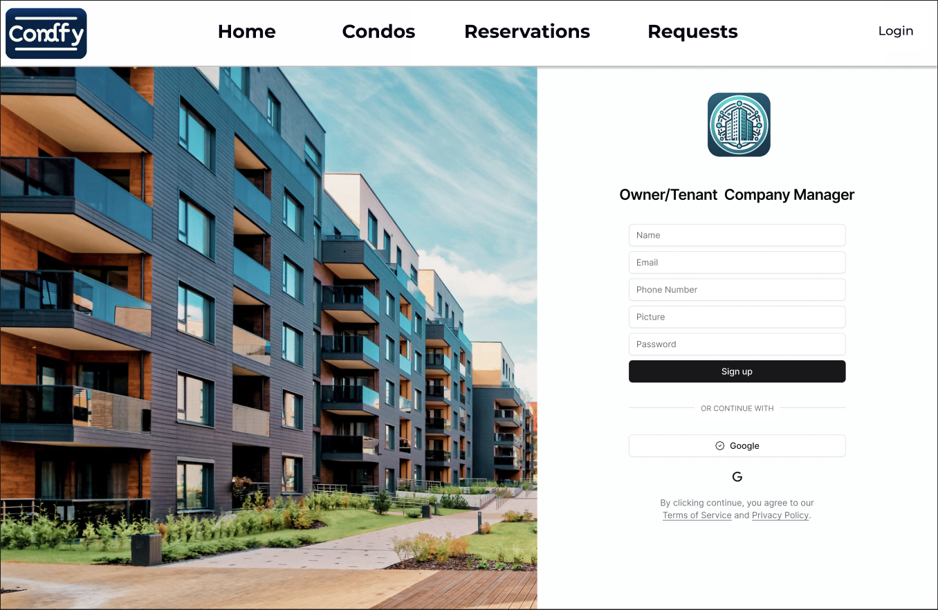

Steps:

1. The user navigates to the "Register" page.
2. The user selects their role as either "Owner/Tenant" or "Company Manager" from a dropdown menu or toggle switch.
3. The user completes the registration form by entering their name, email, phone number, and attaching a picture.
4. The user creates a password and clicks the "Sign up" button.
5. Alternatively, the user can choose to sign up with their Google account for convenience.
6. Upon successful registration, the user is redirected to their dashboard.

**User Story for Login:**

US-2: As an existing user, I want to log into my account to access my personalized condo management features.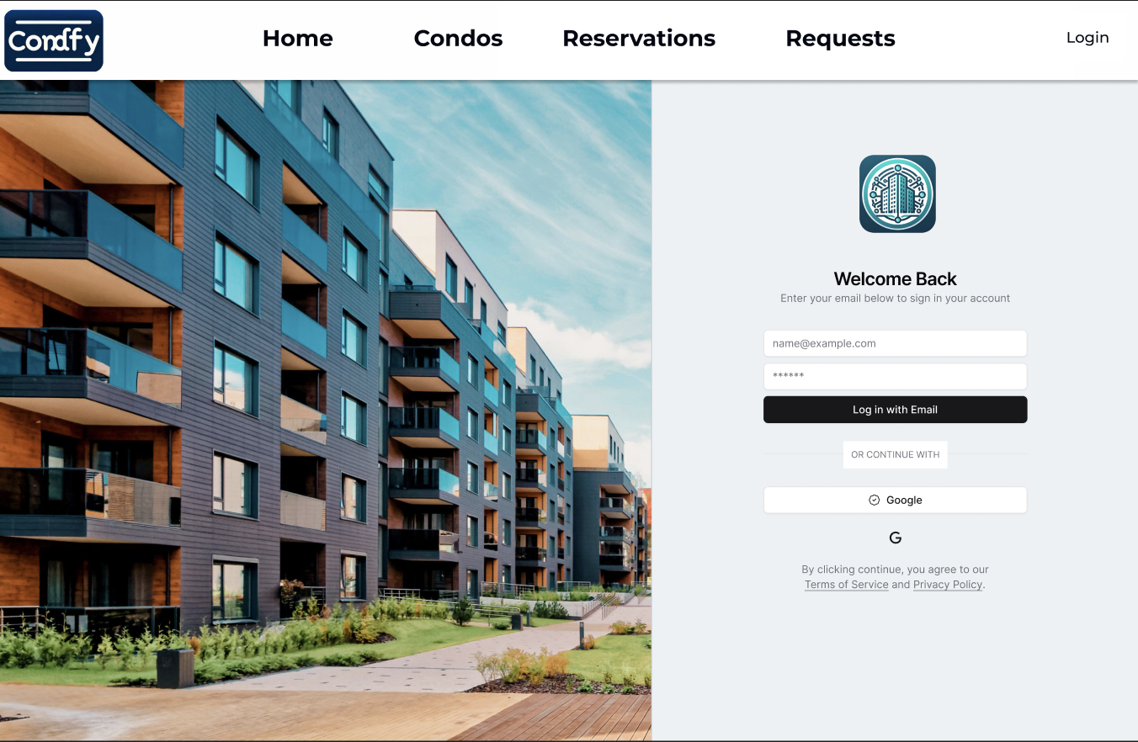

Steps:

1. The user opens the "Login" page.
2. The user enters their registered email and password into the login form.
3. The user clicks the "Login with Email" button to access their account.
4. Alternatively, the user can log in using their Google account by clicking the Google button.
5. The user is then taken to their dashboard where they can view and manage their condo-related information and tasks.

**User Story for Management Page:**

US-3: As a condo manager, I want to navigate to different management sections such as properties and employees so that I can separately manage each aspect of the condo.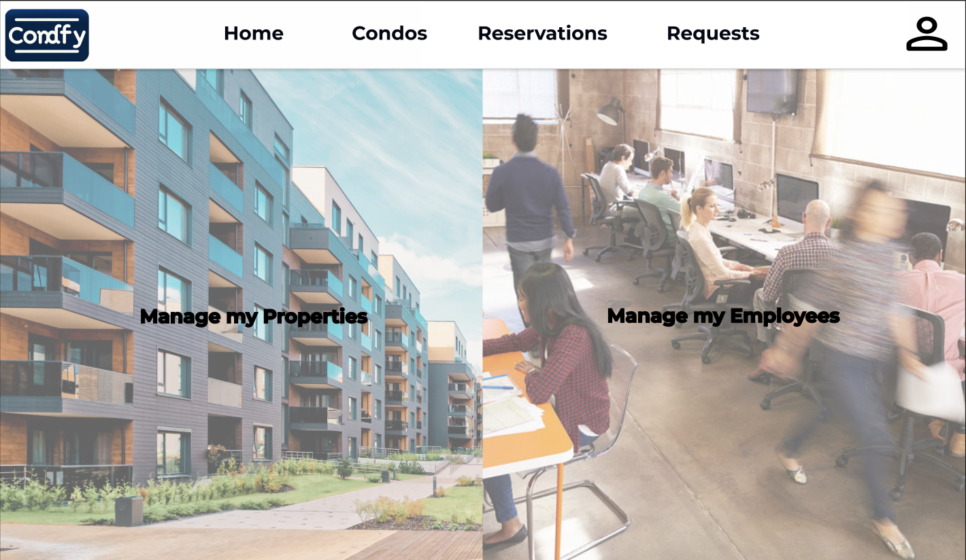

Steps:

1. The condo manager accesses the 'Management Page' after logging in.
2. The manager has the option to select 'Manage my Properties' or 'Manage my Employees', which redirects to the respective management page.

**User Story for Property Dashboard:**

US-4: As a condo manager, I want to view a list of all my properties in one place so that I can easily manage and access specific property details.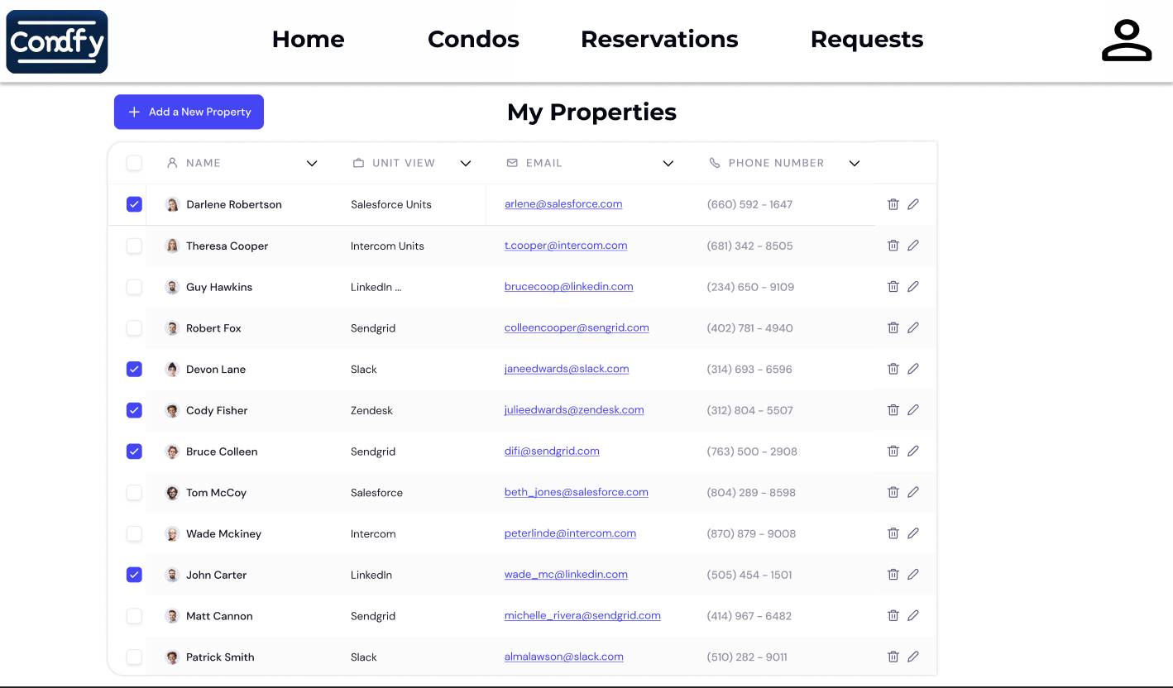

Steps:

1. The condo manager logs in and lands on the 'Property Dashboard'.
2. The dashboard displays a list of properties with details such as property number, address, email, phone number, and action buttons for edit and delete.
3. The manager can sort or search the list for efficient management.

**User Story for Manage My Employees:**

US-5: As a condo manager, I want to manage my employees, view their details, and perform actions like editing and deleting their information.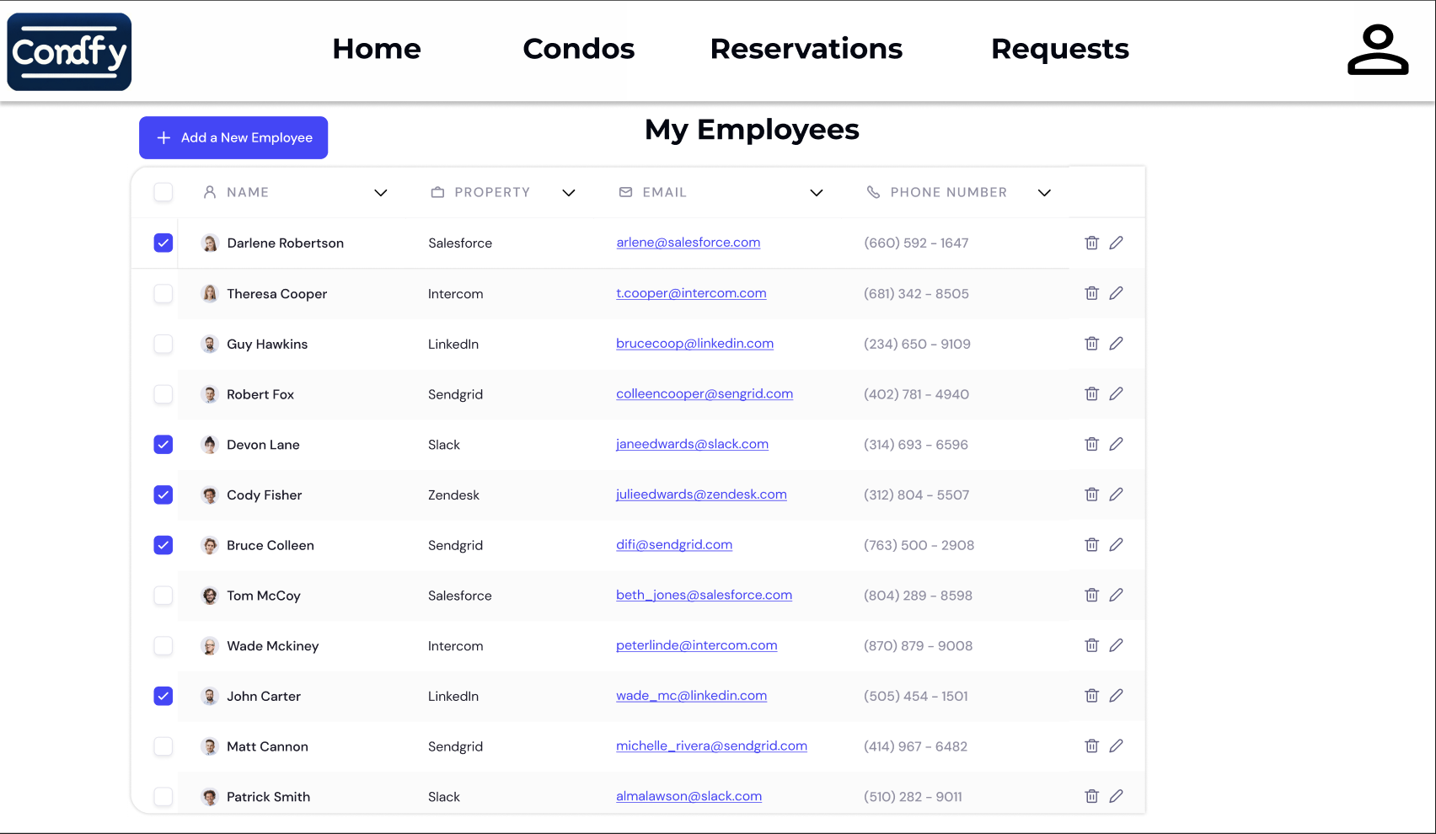

Steps:

1. On the 'Manage my Employees' page, the manager sees a list of employees with details such as staff ID, property they work at, email, and phone number.
2. Action buttons are available for each employee to edit details or remove the employee from the system.

**User Story for Employee Registration:**

US-6: As a condo manager, I want to register new employees to my management system so that they can be assigned tasks and managed within the platform.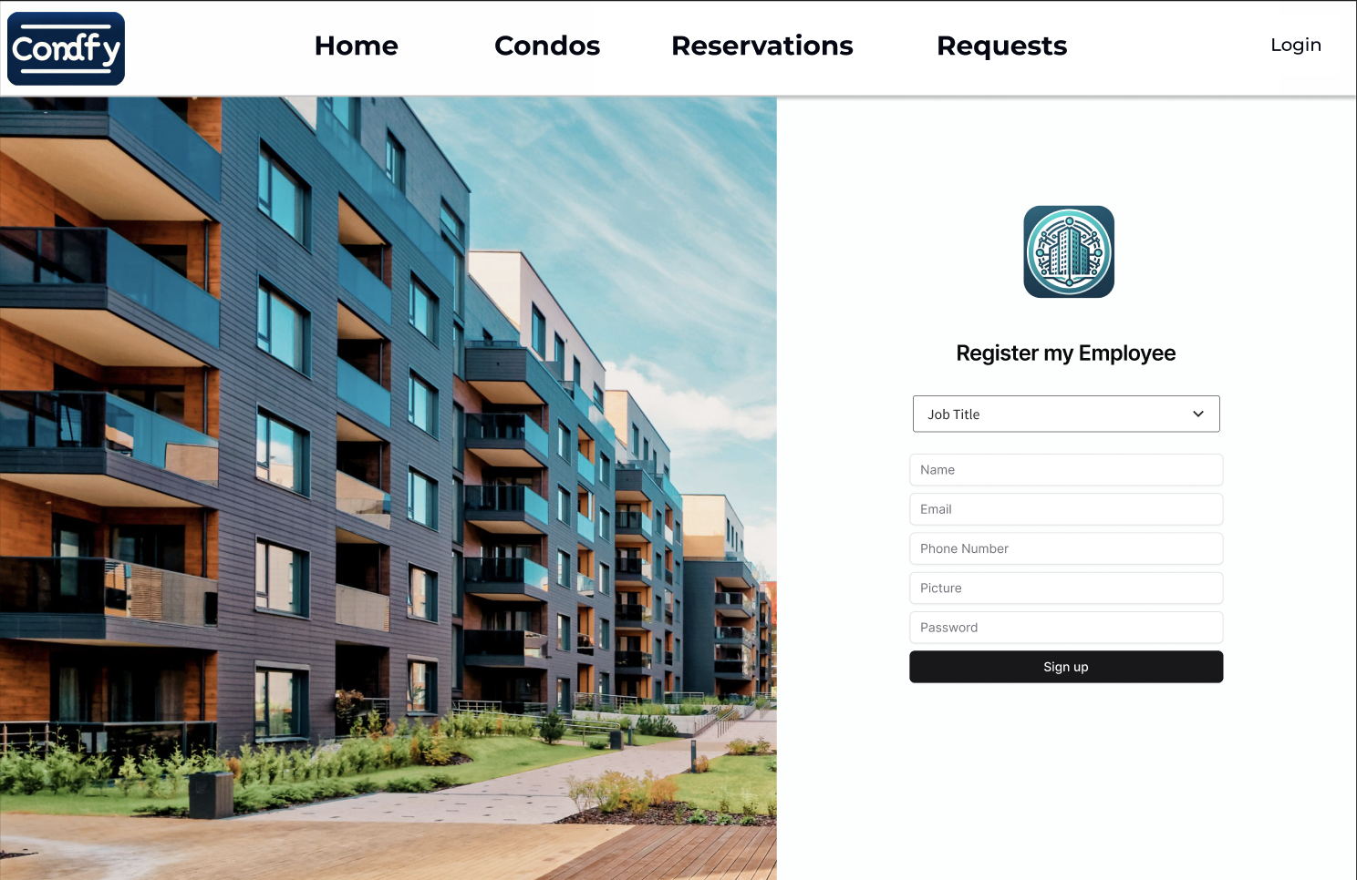

Steps:

1. The condo manager navigates to the 'Employee Registration' page from the management dashboard.
2. The manager fills in the employee's details such as name, email, phone number, and assigns a picture.
3. Upon submitting the form, the employee is registered and added to the 'Manage my Employees' list.

**User Story for Units Dashboard:**

US-7: As a property manager, I want to see a dashboard of all units within a specific property to manage them efficiently.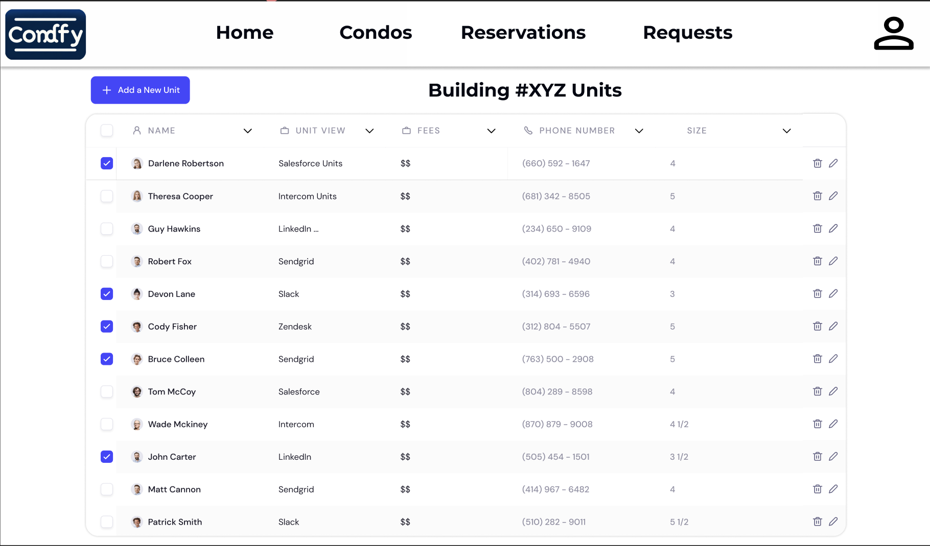

Steps:

1. The property manager selects a property and is directed to the 'Units Dashboard' for that property.
2. The dashboard displays a list of units with details such as unit number, tenant information, lease dates, and financials.
3. The manager can perform actions like editing unit details, contacting tenants, or updating lease statuses.

**User Story for Create Property Profile:**

US-8: As a property manager, I want to create a new property profile to add to my management portfolio.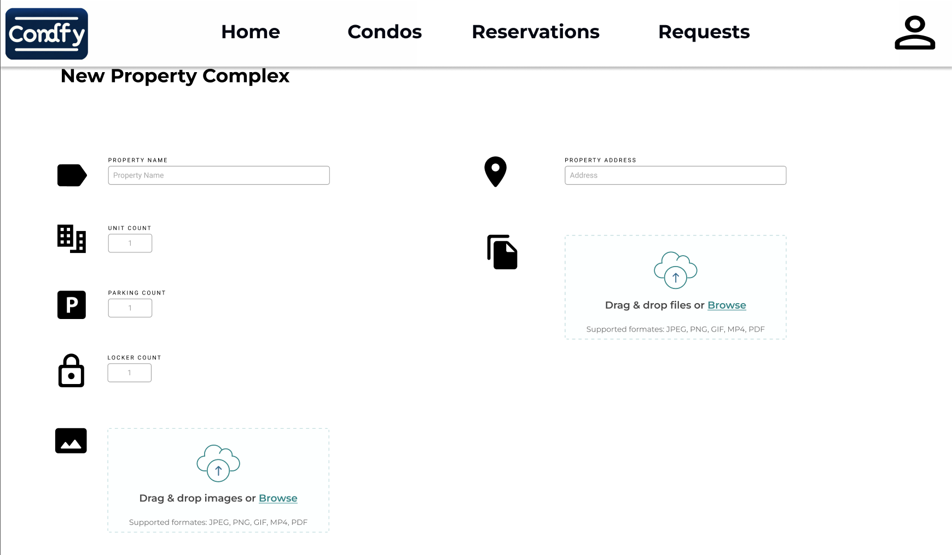

Steps:

1. The property manager navigates to the 'Create Property Profile' page.
2. The manager inputs information such as property name, address, number of units, and uploads images and documents related to the property.
3. Upon submission, the new property is created and added to the manager's portfolio.

**User Story for Create Unit Profile:**

US-9: As a property manager, I want to add individual unit profiles within a property to detail their specific information.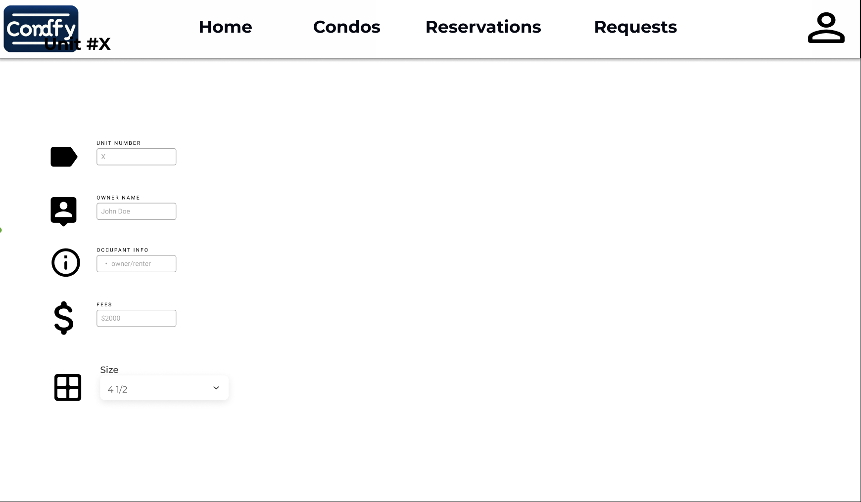

Steps:

1. From within a property's profile, the manager clicks 'Add Unit' to create a new unit profile.
2. The manager enters details like unit number, size, rent amount, and attaches relevant images or documents.
3. After saving, the new unit profile is listed within the property's overall unit list.

**User Story for User Profile Page:**

US-10: As a condo resident or owner, I want to view and edit my personal profile information within the application to keep my contact details up to date.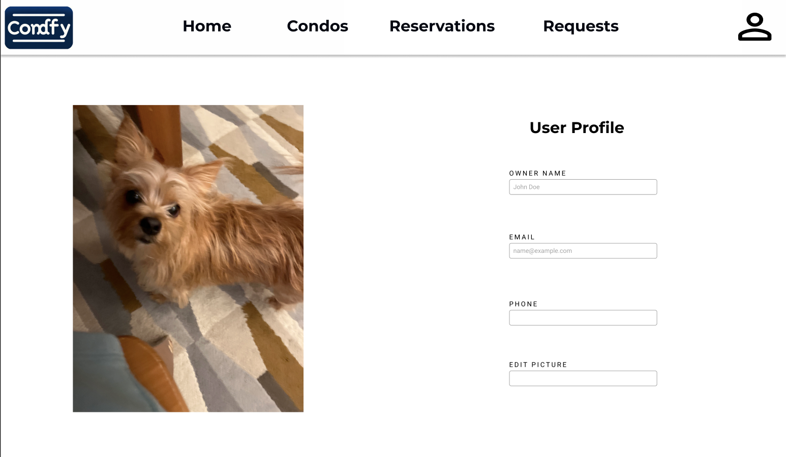

Steps:

1. After logging in, the user navigates to the 'User Profile' page, where their current information is displayed.
2. The user can view their name, email, and phone number as saved in the application.
3. The user has the option to edit any of their personal information, including the ability to change their profile picture.
4. After making the desired changes, the user can save the updates, which are immediately reflected in their profile.

# **Testing Plan**

## Testing Tools and Approach

The test-driven approach is beneficial for several reasons. Firstly, it encourages developers to clearly define the expected behavior of their code upfront through well-defined test cases. This helps in understanding the problem domain and desired outcomes more clearly. Secondly, it promotes an iterative and incremental development process, allowing developers to build and improve the codebase incrementally while ensuring compatibility with existing functionality. Additionally, by constantly running tests and ensuring that all code changes pass the defined test cases, developers can catch bugs and errors early in the development cycle, leading to more robust and maintainable code. Overall, adopting the test-driven approach helps enhance the quality, reliability, and maintainability of the software product while accelerating the development process.

The project makes use of important tools to for manual testing and to ensure high code coverage:

### Code Coverage:

* **Utilization of Jest**: Leveraging Jest for code coverage metrics facilitates comprehensive evaluation of line, function, statement, and branch coverage.
* **Aim for High Coverage Percentage**: Striving for a high code coverage percentage ensures thorough testing and validation of the codebase, leading to enhanced robustness and reliability.

### Tools for Manual Testing:

* **Postman**: Utilizing Postman facilitates the testing of endpoints and verifies seamless communication between different components of the backend system.
* **MongoDB**: MongoDB offers a user-friendly GUI that allows for copying important information for testing requests, as well as checking that operations were successful.

Now for the types of testing:

### Manual Testing:

* **Depth Testing**: Each developer assumes responsibility for meticulously testing their respective codebase to ensure comprehensive coverage. Tools like Postman and MongoDB’s GUI are used extensively.
* **Test-driven Approach**: Adhering to the test-driven development (TDD) methodology involves crafting tests before writing actual code. This ensures alignment with specified requirements and facilitates long-term maintainability.
* **Periodic Code Reviews**: Conducting regular code reviews provides opportunities to identify and address any emerging issues, fostering a culture of continuous improvement.

### Developer-level Testing:

* **Endpoint Testing**: Developers conduct rigorous testing of endpoints to validate their functionality.
* **MongoDB GUI**: Utilizing MongoDB GUI allows for convenient verification of object creation or modification, depending on the operation.
* **CRUD Operation Testing**: Comprehensive testing of CRUD (Create, Read, Update, Delete) operations ensures the robustness and reliability of the system under various scenarios.

### Unit Testing:

* Unit testing has been in progress from the first sprint. During the second sprint we investigated easier ways to create unit tests and decided to use NestJs’ built in testing, along with mockingoose. Mockingoose is a library that allows developers to mock database actions, to avoid real read and write operations to the database. The new approach has been employed and will be used for the remainder of this project.
* To ensure that high statement coverage is met, GitHub actions has been configured to give a report of test coverage in every PR. This will ensure that for all features there is sufficient testing.

### Integration Testing:

* Integration testing is an important part of testing, as it ensures that different components work together. For the purposes of the backend testing that we are focusing on, this means testing an entire module from end to end.
* Integration testing will be implemented to simulate the expected interaction with the production system. Automated integration testing will ensure no unintended breaking changes are introduced, because it will be harder to manually test the end-to-end behavior of each API endpoint.
* Developers will use NestJs’ end-end testing to write end-to-end tests that testing the full behavior of API endpoints. The tests will mock a REST API request coming from the front end, to ensure that no breaking changes are introduced.
* Integration testing is of the upmost important as we approach release and aim to stabilize production.

### 

## Metrics and Coverage

### Code Metrics:

In the previous sprint we discussed the possibility of employing SonarQube for measuring important metrics. However, SonarQube and many other similar tools only offer a free trial, full access to the product is expensive.

Moreover, after more through investigations we have decided to use Codacy. Codacy is a quality and security analysis tool, that has been configured to give important measures for both the web application and mobile application. The tool runs automatically on every PR, as well as the main branches.

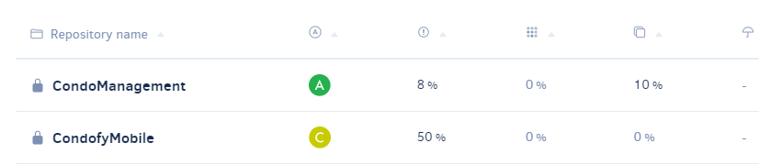

Taking a closer look at the CondoManagement repo, which contains the frontend for the web application, as well as the main backend, we can see that the tool gives a quality evolution chart, and a breakdown of issues.

The code evolution chart displays the percentage of issues (code style, error prone, best practice, security related issues), complexity (percentage of complex files), and code duplication.

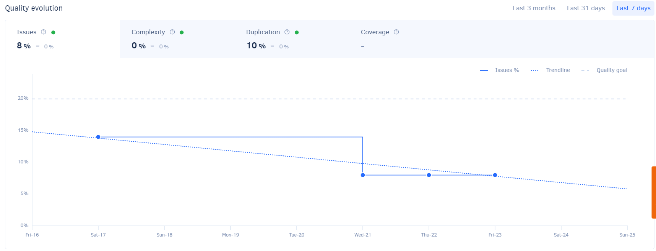

Moreover, Codacy gives a breakdown of issues and categorizes them so that they can handled according to their priority.

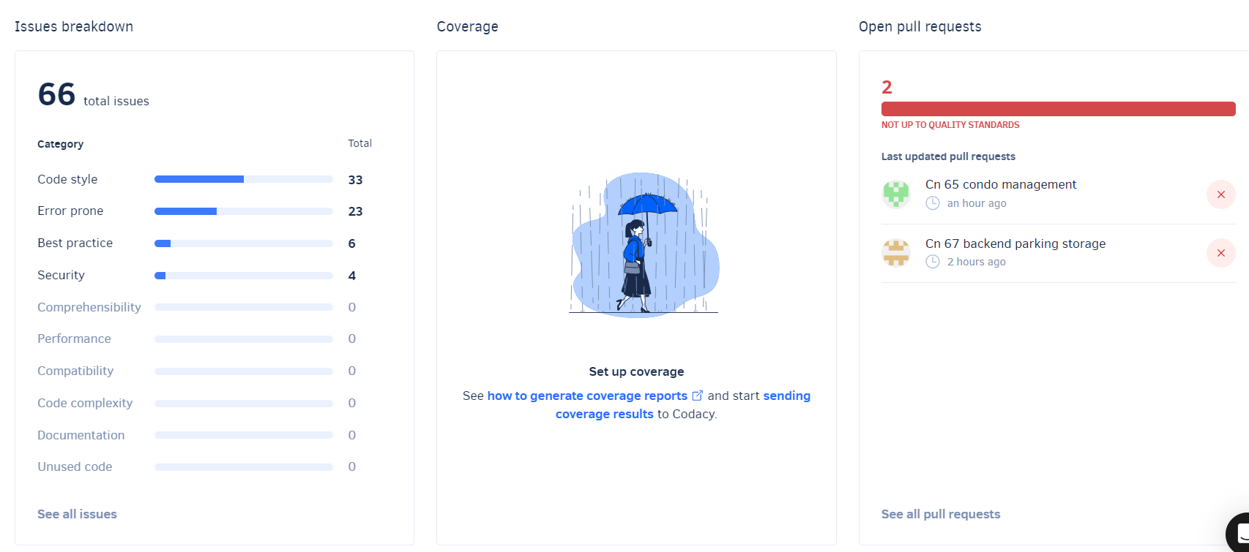

Moreover, upon clicking on one of the issues’ categories it gives a list of issues with their urgency.

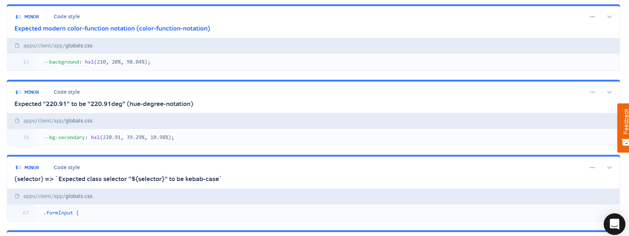

The tool also gives an overall grade for each file and breakdown of each file and commit.

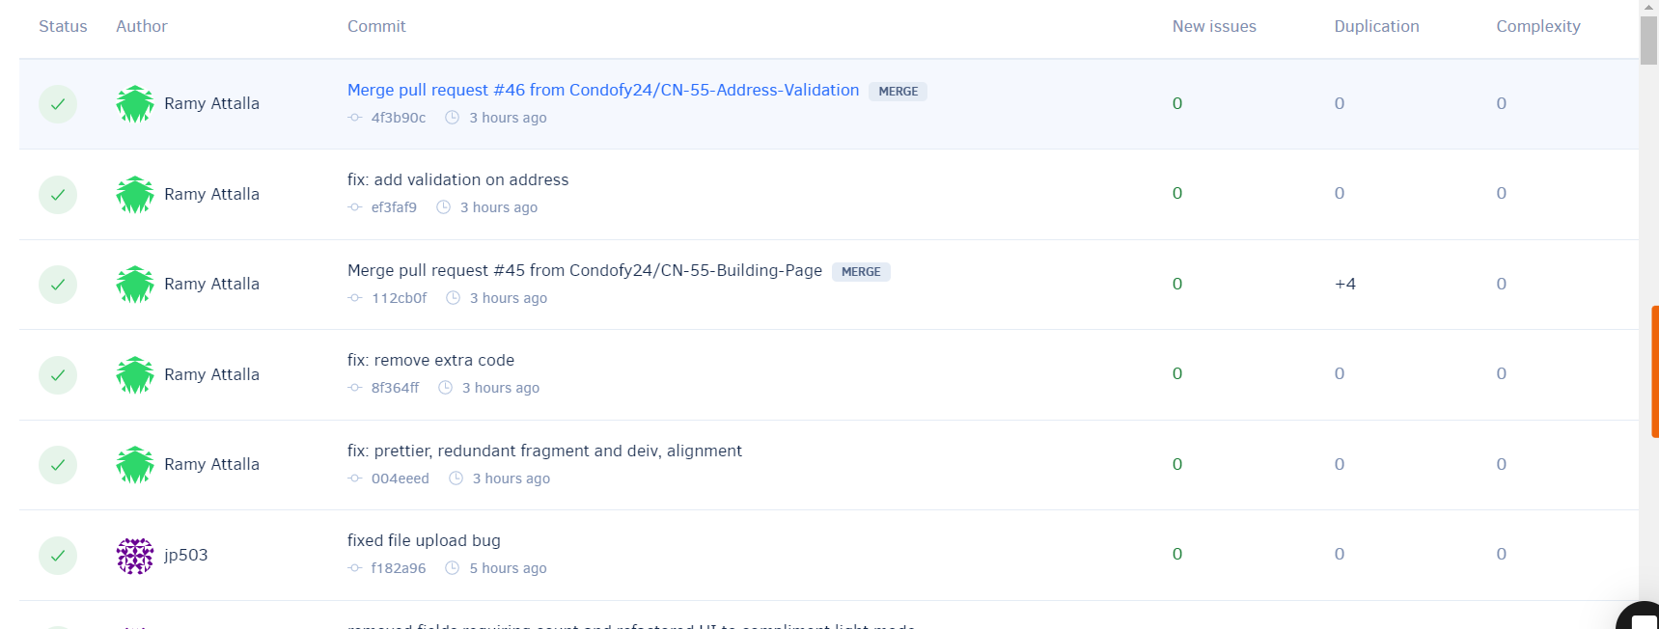

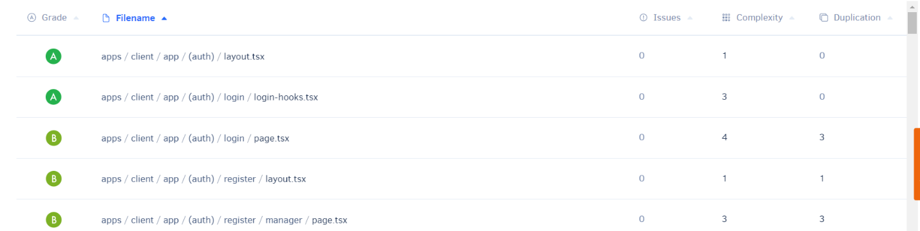

Moreover, the tool also analysis code patterns.

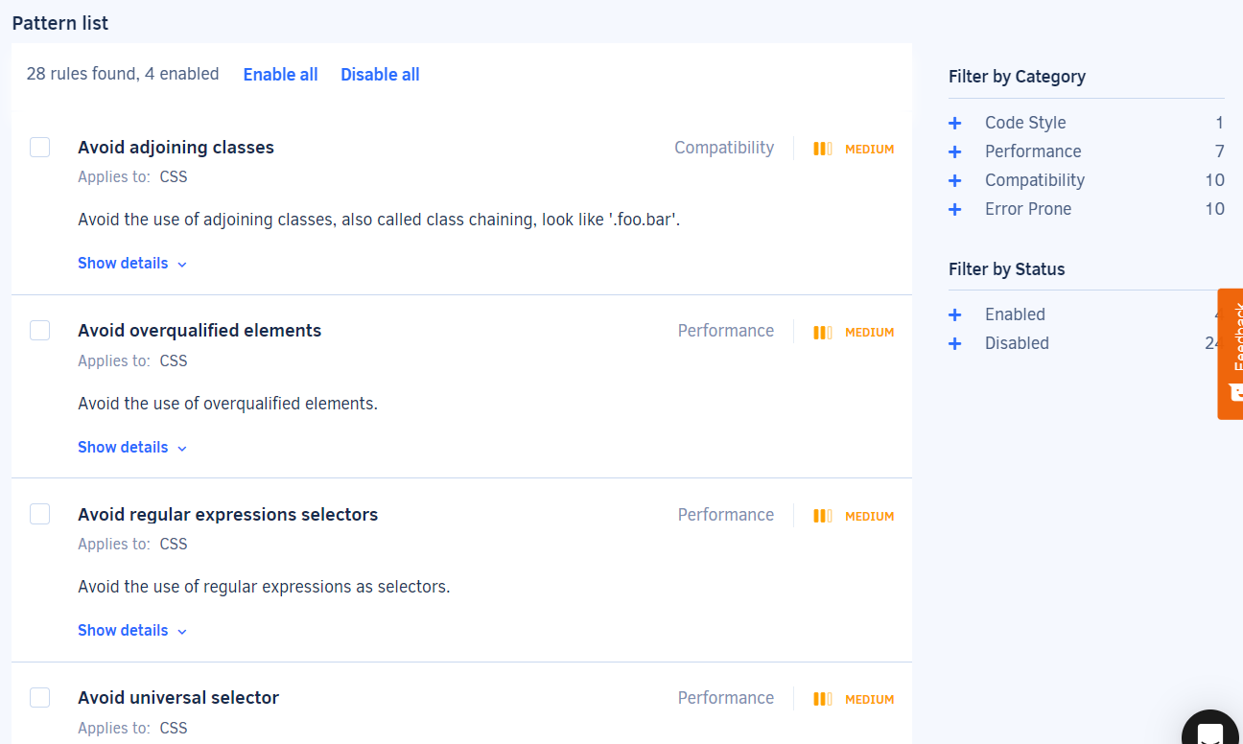

In future sprints, Codacy will be used more closely to ensure that high priority issues are fixed, and code is refactored to meet high quality exceptions and follow patterns. This will allow for less fixes to be required as the project grows, since the height quality code will allow for easier maintainability. To summarize sprint 4 will make use of the following metrics:

* Overall code duplication.
* Code style issues.
* Error prone issues.
* Best practice-related issues.
* Security issues.
* File grades, complexity, and duplication (which effects the overall percentages.)

## Test Execution

During the development phase, developers will execute manual tests as an integral part of their workflow. Additionally, backend testing utilizing Postman will focus on thoroughly assessing endpoints and ensuring seamless communication between components. Furthermore, Jest will be leveraged for implementing a test-driven development approach and monitoring code coverage.

## Test Environment

To ensure consistency and isolation during testing, Docker will be utilized to set up a standardized test environment. This approach enables the creation of reproducible testing environments across different development setups, minimizing potential discrepancies and ensuring uniformity in test results. By employing Docker, we can streamline the process of environment setup, deployment, and configuration, thereby enhancing the efficiency and reliability of our testing procedures.

## Sprint 3

### Acceptance Test Scenario

Scenario: Manager View Employees

1. Manager visits Condofy
2. Manager navigates to “Manage Employees” page.
3. Expected: A table with all the employees of the company with ability to delete any of them.

Scenario: Manager Deletes Employee

1. Manager visits Condofy
2. Manager navigates to “Manage Employees” page.
3. Manager chooses an employee and presses on the right-aligned dropdown in their row and presses delete.
4. Expected: A pop up asks them to confirm their actions.
5. Manger
   1. Confirms:
   * Expected: The user is deleted.
   1. Cancels
   * Expected: Returned to “Mange Employees” page.

Scenario: Manager Creates Employee

1. Manager visits Condofy
2. Manager navigates to “Manage Employees” page.
3. Manager clicks “Add Employee.”
4. Manager enters the required information.
5. Expected: Employee is created, and a success toast is dispatched

Scenario: Mobile User Signs Up

1. User visits Condofy Mobile
2. User enters their information and registration key
3. Expected: User is registered and navigated to sign in screen

Scenario: Mobile User Modifies Profile

1. User visits Condofy Mobile
2. User signs in
3. User navigates to “Profile.”
4. Users changes data they want to update.
5. User clicks “Update”
6. Expected: User’s information is updated, and success message is dispatched.

Scenario: Owner Views Units

1. Owner visits Condofy
2. Owner signs in
3. Owner navigates to “Dashboard”
4. Expected: Owner can view all their units.

Scenario: Owner Views Financial Status For a Unit

1. Owner visits Condofy
2. Owner signs in
3. Owner navigates to “Dashboard”
4. Owner chooses one of their units.
5. Expected: Owner can see their financial status and download a report

Scenario: Manager Updates Financial Status of a Unit

1. Manager visits Condofy
2. Manager signs in
3. Manager navigates to “Properties.”
4. Manager chooses one of their units.
5. Manager adds paid amount.
6. Expected: Financial Status of unit is updated with the new balance

## Sprint 4

### Acceptance Test Scenario

Scenario: Manager View Employees on Mobile

1. Manager visits Condofy Mobile.
2. Manager navigates to “Manage Employees” page.
3. Expected: A table with all the employees of the company with ability to delete any of them.

Scenario: Manager Deletes Employee on Mobile

1. Manager visits Condofy.
2. Manager navigates to “Manage Employees” page.
3. Manager chooses an employee and presses on the right-aligned dropdown in their row and presses delete.
4. Expected: A pop up asks them to confirm their actions.
5. Manger
   1. Confirms:
      1. Expected: The user is deleted.
   2. Cancels
      1. Expected: Returned to “Mange Employees” page.

Scenario: Owner Views Units on Mobile

1. Owner visits Condofy.
2. Owner navigates to “Properties”
3. Owner can view all units and their parkings, and storages

Scenario: Employee Views Reservations

1. Employee visits condofy
2. Employee navigates to reservations
3. Employee can select a building
4. Employee can view reservations of a building by clicking it

# **Code Management**

# Design Patterns

## Singleton Pattern

We have implemented a theme management strategy that aligns with the Singleton design pattern in our React application. We use React's createContext API to create a Theme Context that centralizes our theme's state and behavior, making it easily accessible to all components in our application. This centralized theme state ensures a consistent visual experience for our users and always maintains a single active theme.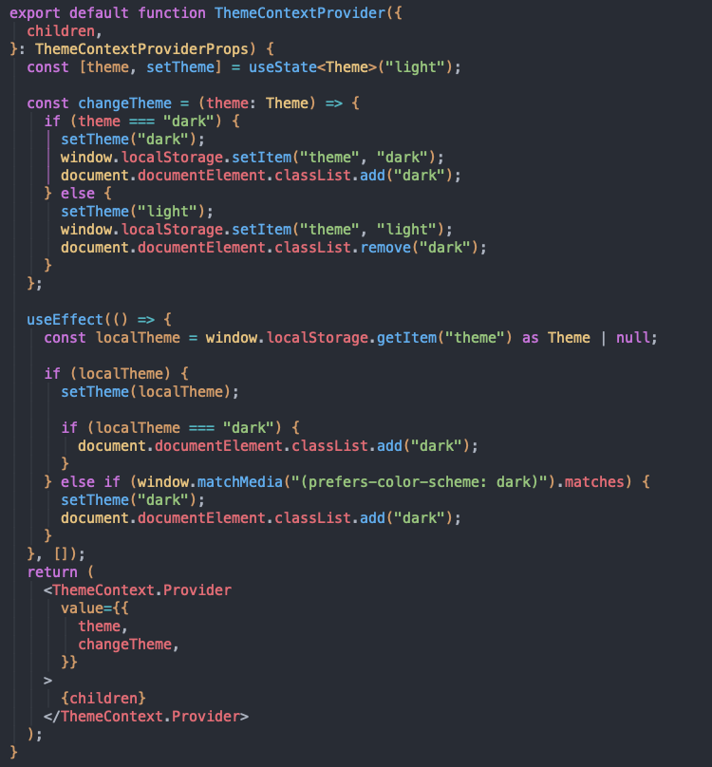

Following the Singleton pattern, our Theme Context design ensures that any updates to the theme are immediately reflected across all components, providing a cohesive user experience. Our ThemeContext.Provider includes the theme's state and a changeTheme function that allows users to toggle between the "light" and "dark" modes. This approach eliminates the complexities associated with handling different theme state instances and establishes a reliable and efficient theme switching mechanism.

This approach is particularly beneficial for complex applications like ours, where multiple components need to respond to theme changes. It simplifies the propagation and synchronization process, leading to improved developer efficiency and user satisfaction.

## Observer Pattern

We have decided to use Redux due to its robust state management capabilities that are crucial to the smooth and consistent operation of our application. Redux uses the observer pattern, which is central to our architectural strategy, ensuring that our application's state is always consistent and coherent. We have made the Redux store the cornerstone of our design, as it acts as the single source of truth. It contains all the essential state information, including critical authentication details. This centralization simplifies state management, allowing us to maintain a clean and organized codebase.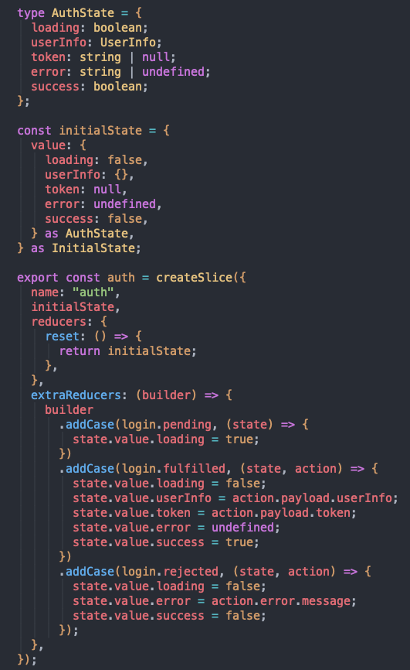

Most of the actions that takes place within our application triggers the Redux observer pattern mechanism, which in turn updates the application state through our reducers. For instance, when a user logs in, the relevant reducers are engaged to accurately reflect the user's state change. This mechanism is crucial to preserving the structural integrity of our application and ensures that our user interface accurately mirrors the application's current state.

The flexibility that Redux offers is another reason why it is integral to our application. The ability to integrate additional reducers seamlessly enables us to introduce extra features and functionalities. This adaptability, which is a hallmark of the observer pattern, is what makes Redux a sturdy and versatile state management framework.

## Model-View-Controller (MVC)

We use the Model-View-Controller (MVC) design pattern in our backend architecture to create a clear separation of concerns and a maintainable codebase. The Controller component orchestrates interactions between our application's frontend and backend layers.

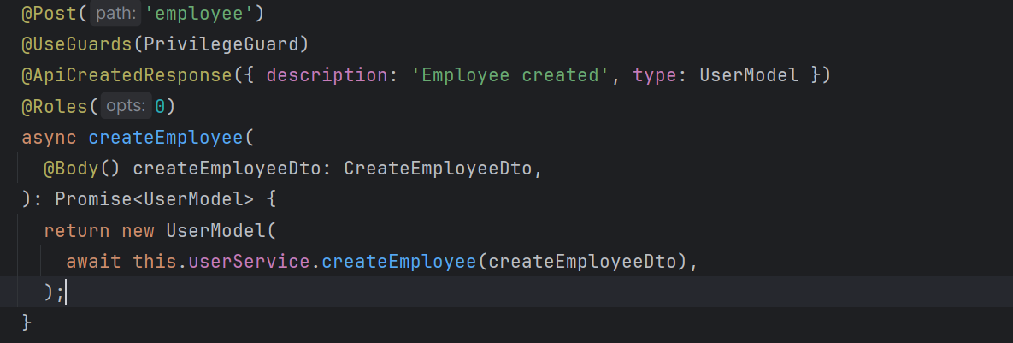

In the provided example, we showcase the role of the Controller. Within our codebase, for example, in the createEmployee function, the Controller receives frontend requests, interacts with the appropriate services, and orchestrates the creation of new employee entries in the system. This demonstrates the Controller's primary responsibility of guiding calls from the frontend to the backend, where the business logic sits.

Furthermore, in our MVC architecture, the View, represented by the frontend, interacts with the Controller by making API requests. By adhering to this pattern, we establish a scalable and flexible architecture that allows for easy integration of new features and enhancements.

# Source Code Documentation

We emphasize the meticulous application of TSDoc standards that contribute to a well-documented codebase, enhancing readability and maintainability. As an example, the UserService class, as part of our application's backend services, is thoroughly annotated following TSDoc conventions. This documentation provides clear guidance on the responsibilities of the UserService, which include user creation, retrieval, update, and deletion.

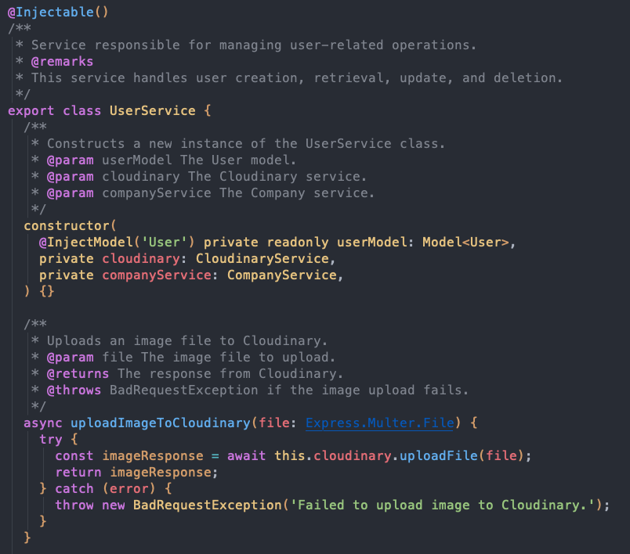

Constructor parameters are well-defined, specifying dependencies such as UserModel, CloudinaryService, and CompanyService, which are integral to the UserService's operation. Furthermore, each method within the UserService is accompanied by descriptive comments that outline the purpose, parameters, expected return types, and possible exceptions thrown during execution. For example, the `uploadImageToCloudinary` method description clarifies its role in image handling, while the `createManager` method documentation ensures that developers are aware of the method's input requirements, operational details, and error handling procedures.

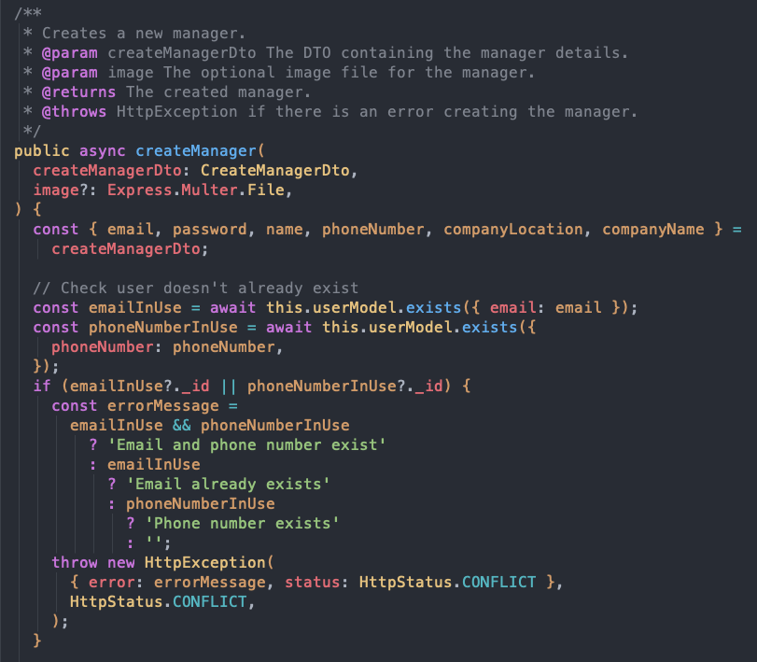

The building controller is a crucial component of our backend architecture, it is properly documented to ensure clarity in its role for managing building-related operations. The class is decorated with a @Controller annotation, specifying its route at the 'building' endpoint.

Two primary operations are detailed: create and update. Both methods are accompanied by comments that describe their functionality, accepted parameters, and expected outcomes. The create method is responsible for constructing a new building entity, accepting parameters such as companyId and createBuildingDto, with an additional capability to handle file uploads, as indicated by the @UploadedFile decorator. Similarly, the update method is designed to modify existing building records, as indicated by its parameters and decorators.

By adhering to TSDoc standards, we ensure that our codebase remains accessible and intelligible not only to the current development team but also to any future contributors or stakeholders who may interact with Condofy's code.

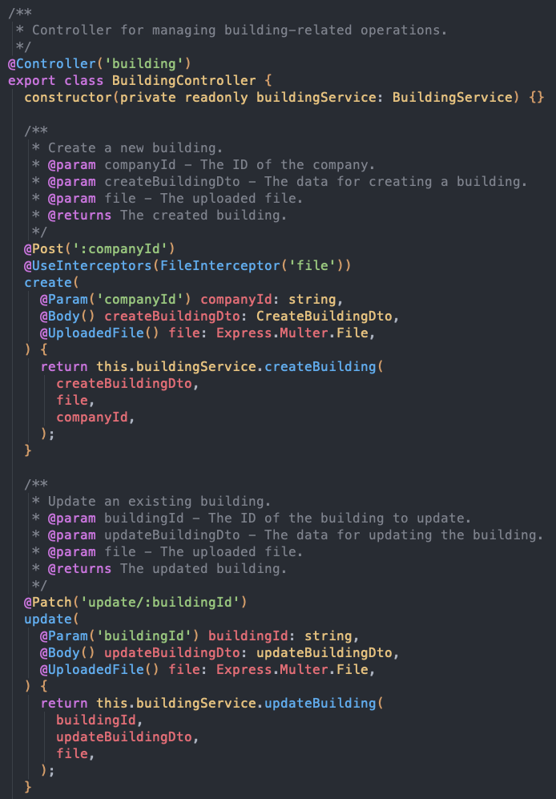

## Bug Report

| **Bug ID** | CN-148 | | |
| --- | --- | --- | --- |
| **Originator** | Khashayar Azad | Email: khashayar1924@gmail.com | Signature: khashazad |
| **Submit Date** | 03/12/2024 | | |
| **Summary** | Owners are unable to claim multiple properties. This issue prevents owners from managing multiple units, impacting user experience and operational efficiency. | | |
| **Severity** | Major | | |
| **Product** | Website | | |
| **Component** | Database | | |
| **Platform** | Mac | | |
| **OS** | Mac | | |
| **Browser** | Chrome | | |

| **Bug ID** | CN-147 | | |
| --- | --- | --- | --- |
| **Originator** | Khashayar Azad | Email: khashayar1924@gmail.com | Signature: khashazad |
| **Submit Date** | 03/10/2024 | | |
| **Summary** | On the sign-up page, the input field for the registration key is missing. This field is crucial for users who are trying to sign up with a registration key provided to them. Without this field, users cant be linked to units as owners/renters. | | |
| **Severity** | Major | | |
| **Product** | Website | | |
| **Component** | Front-end | | |
| **Platform** | Mac | | |

| **Bug ID** | CN-168 | | |
| --- | --- | --- | --- |
| **Originator** | Ramy Attalla | Email: ramysamerattalla@gmail.com | Signature: ramyattalla |
| **Submit Date** | 03/24/2024 | | |
| **Summary** | Backend - Cannot give Roles multiple values;  Cannot give @Roles multiple values to allow for multiple types of users to interact with the endpoint | | |
| **Severity** | Major | | |
| **Product** | Website | | |
| **Component** | API | | |
| **Platform** | PC | | |
| **OS** | Windows | | |
| **Browser** | Chrome | | |

| **Bug ID** | CN-182 | | |
| --- | --- | --- | --- |
| **Originator** | Ramy Attalla | Email: ramysamerattalla@gmail.com | Signature: ramyattalla |
| **Submit Date** | 03/30/2024 | | |
| **Summary** | Allow delete facility;  Managers should be able to delete facilities and this should cascade to related availabilities and reservations | | |
| **Severity** | Major | | |
| **Product** | Website | | |
| **Component** | Front-end | | |
| **Platform** | PC | | |

# Design Quality

## Modularization

Our application is architected to prioritize high cohesion within modules and low coupling between them, leveraging the robust modular system provided by the NestJS framework. This design approach is evident in how we have organized our controllers and services.

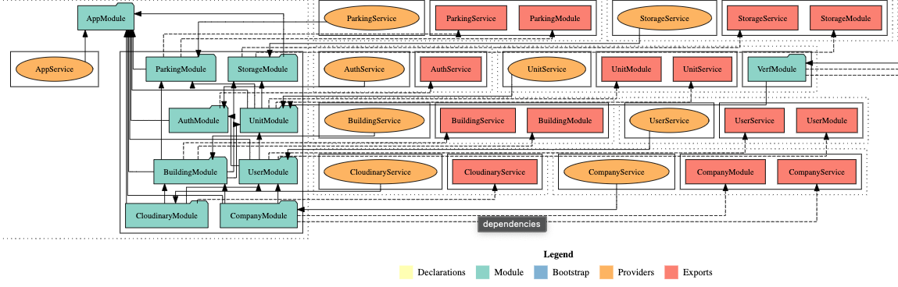

Cohesion through Functionality-Based Grouping

By taking full advantage of NestJS's module-based architecture, we have grouped related functionalities into distinct modules. For instance, our UserModule encapsulates all the controllers and services related to user operations, while CompanyModule and CloudinaryModule manage company and media-related functionalities, respectively. This grouping ensures that each module is a high-cohesion unit, focused on a single aspect of the application's functionality.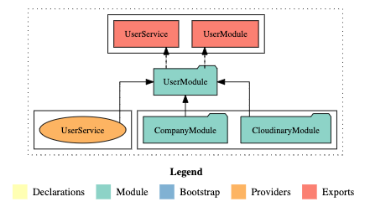

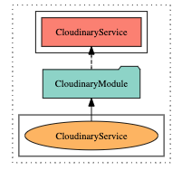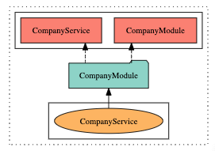

Low Coupling with Well-Defined Interdependencies

The interdependencies between modules are carefully managed and minimized. As depicted in the above diagram, UserService is used within UserModule, demonstrating a direct but contained relationship. This careful structuring ensures that modules interact with each other only when necessary and through well-defined interfaces, which reduces coupling.

Benefits of Modular Design

The result of this strategic modularization is a codebase where each module can be developed, tested, and debugged in isolation or in conjunction with others with minimal impact. It enhances the maintainability of the code, as changes in one module have a reduced chance of adversely affecting others. Furthermore, our approach simplifies the process of onboarding new developers, as the functionality-based grouping provides a clear roadmap of the application's structure.

Scalability and Flexibility

Lastly, our module-based design offers scalable and flexible solutions to future development. New features can be seamlessly integrated by adding new modules or expanding existing ones, without the need for large-scale refactorings. This strategic approach not only improves current development workflows but also sets a solid foundation for the application's long-term evolution.

## Refactoring Efforts

As part of our comprehensive backend overhaul, we made a strategic decision to separate the core data structures, known as entities, from the user-facing data representations, or models. The previous architecture had these two intertwined, resulting in difficulties in adapting the application, safeguarding data, and customizing the user interface.

In our approach, we utilized an intermediary translation layer, which is illustrated in the above figure. The “UnitEntity”, which serves as the backbone data structure, undergoes a systematic transformation into a UnitModel before being transmitted to the client. This process guarantees that any internal modifications will not affect the user interface, and vice versa.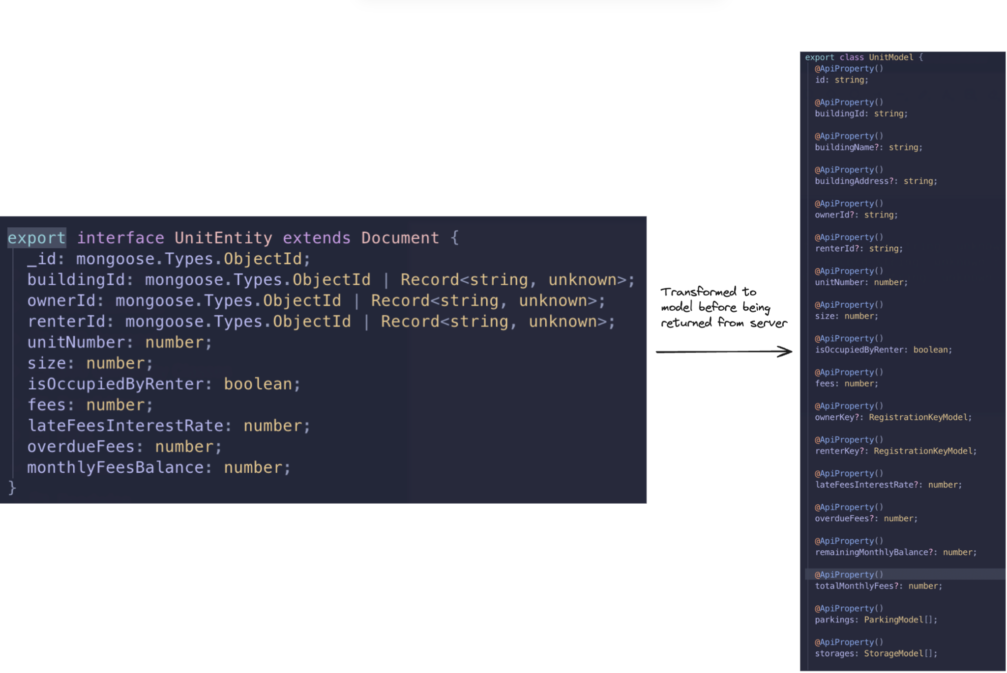

We improved our data management by implementing design patterns and conversion tools that facilitate efficient data mapping. For instance, we changed the monthlyFeesBalance attribute in the entity to remainingMonthlyBalance in the model. These enhancements not only strengthened the security and flexibility of the app but also made future updates more straightforward. By creating a modular and forward-thinking backend structure, we established a solid foundation for the app's continued development and scalability.

# Static Analysis & Code Review Tools

Importance

The integration of a static analysis tool that runs on every pull request (PR) plays a pivotal role in maintaining and elevating the overall quality of codebases within software development projects. By systematically examining code for quality, style errors, and ranking issues, this process ensures that code adheres to established best practices, coding standards, and project-specific guidelines. The significance lies in its ability to catch potential issues early in the development lifecycle, fostering a proactive approach to code review and enhancement. This real-time feedback loop not only streamlines the code review process but also cultivates a culture of continuous improvement and collaboration among team members.

Furthermore, the ranking of issues enables developers to prioritize and tackle critical issues first, thereby optimizing resource allocation and maximizing productivity. Ultimately, the integration of static analysis into the PR workflow serves as a linchpin for ensuring codebase integrity, reliability, and maintainability, contributing to the long-term success and sustainability of software projects.

Tool and Metrics

For this project, the static analysis tool being used is Codacy. Codacy runs on both of our repos (Web and Mobile)

Codacy is responsible for measuring:

1. Overall code duplication, issues, and complexity

Overall code duplication refers to code snippets that have been copy pasted, instead of abstracted and reused. Issues refers to different categories of issues, code style issues (for example CSS mistakes), error prone (possible undefines that could lead to bugs), best practice (broken best practices that should be respected) and security (API secrets exposure)

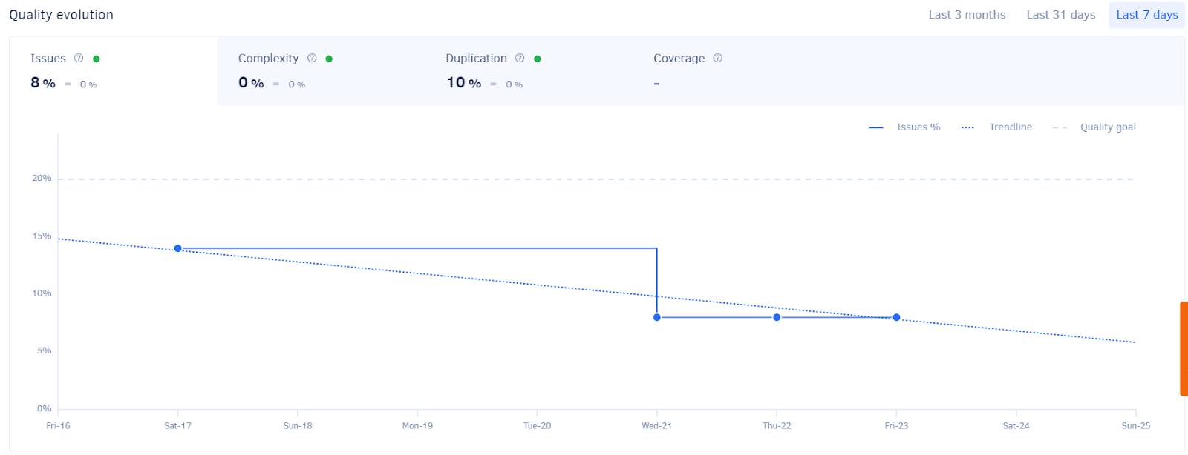

1. Issues: Code style issues, error prone issues, best practice issues, and security issues.

As mentioned above the analyzer detects code style issues, error prone issues, best practice issues and security issues. Moreover, if shows more details when one of the categories are selected. Codacy gives a ranking so that developers can prioritize work and avoid spending time on less critical issues.

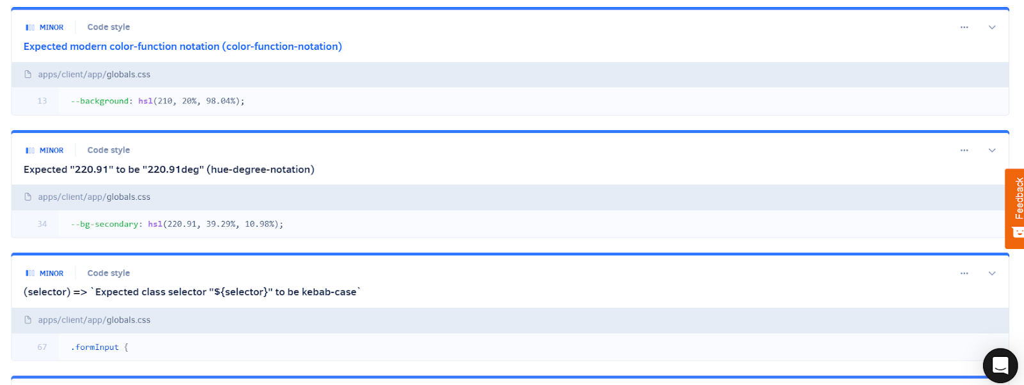

1. File grades, complexity, and duplication (which effects the overall percentages)

The tool gives a grade to each file and counts issues, measures complexity and counts duplication for each file. It also does the same for each commit.



1. Code patterns. 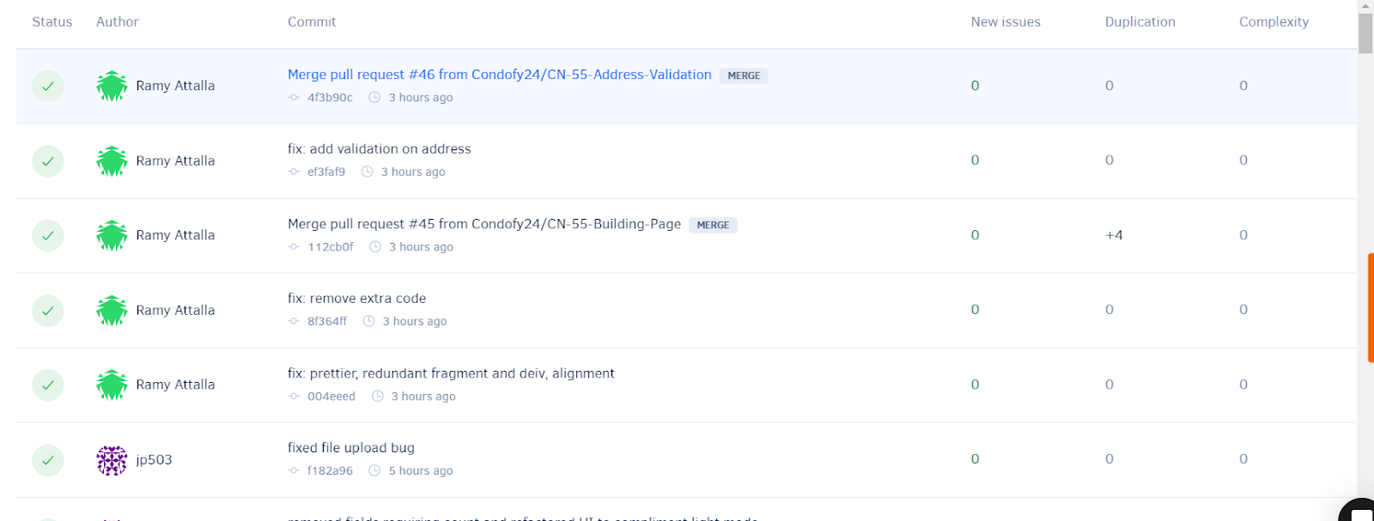

The tool analyzes code patterns and gives suggestions to improve the code. The issues are also ranked to ensure correct prioritization of tasks,



# Use of Feature Branches

All user epics, stories, subtasks, and bugs ("tickets") are meticulously crafted within the user-friendly interface of JIRA, a comprehensive project management tool. JIRA's automatic generation of unique IDs for each ticket, such as "CN-1", serves as a fundamental component for efficient tracking and reference throughout the project's lifecycle. These IDs play a crucial role in monitoring and managing features, allowing for streamlined communication and collaboration among team members.

Furthermore, the implementation of a standardized branch naming convention within the version control system contributes to the systematic organization of the development process. Branch names, exemplified by formats like "CN-31-Frontend-Profile-Page", not only include the ticket number but also provide a brief description of the associated task or feature. These branches serve as representations of feature branches, facilitating easy trackability and establishing direct links to user stories in JIRA. Even bug fixes adhere to this convention, ensuring a consistent approach to monitoring the progress of bugs throughout the sprint. This integration of JIRA, ticket IDs, and branch naming conventions enhances the overall project management experience.

# 

# **Deployment**

The application is deployed on 2 separate servers, one hosting the backend and one hosting the client which communicates with the backend.

The backend server can be accessed through <https://condofy.onrender.com/>, visiting the link displays our sample api endpoint and displays a hello world. More interestingly, the client (most recent version and fully functional with communication to the backend) is hosted here: <https://condo-management-client-ev87301tl-conodfys-projects.vercel.app/>

The mobile app can build using: *npm run build*.

For easy testing of the application the following credentials can be used:

**Credentials:**

Manager:

Email: [manager@email.com](mailto:manager@email.com)

Password: Password1! (capital P)

**Employee:**

Email: employee@company.com

Password: employee_5432187690

**Owner:**

Email: owner@email.com

Password: Password1! (capital P)